

# MIT Art, Design and Technology University MIT School of Computing, Pune

**Department of Information Technology**

# Lab Manual

**Practical - Web Programming**

**Class - S.Y. (SEM-IV), DA**

**Batch - DA-I**

## Name of the Student

**Mr. Abhijeet Pandurang Shirke**

**A.Y. 2024 – 2025 (SEM-IV)**

File Index page given in the stationary

|  |  |  |  |
| --- | --- | --- | --- |
| **Web Programming**  **SEMESTER – IV** | | | |
| **Course Code:** | 23IT2008 | **Course Credits:** | 02 |
| **Teaching Hours / Week (L:T:P):** | 0:0:4 | **CA Marks:** | 25 |
| **Total Number of Teaching Hours:** |  | **END-SEM Marks:** | 25 |
| **Course Pre-requisites:** | | | |
| **Course Description:**  This course provides a comprehensive introduction to web technology, designed to help students develop a strong foundation in building and managing websites and web applications. The curriculum covers key topics such as HTML, CSS, and JavaScript,PHP, MySQL, which are essential for creating interactive, well-designed web pages. Students will also explore the principles of responsive design, ensuring that web applications are optimized for different devices and screen sizes.  The course dives deeper into server-side technologies, including HTTP, web servers, and databases, allowing students to understand how websites function behind the scenes. Emphasis is placed on practical learning, and students will gain hands-on experience by working on projects that showcase their ability to design, develop, and deploy websites.  By the end of the course, students will be proficient in using modern web technologies to create web applications. They will understand how to handle client-server interactions, manage user data, and implement various web technologies to enhance the functionality of their applications. | | | |
| **Course Learning Objectives:** This course will enable the students to:   1. Understand fundamental concepts of front-end web development. 2. Enable students to create basic web pages incorporating essential elements such as images, hyperlinks, lists, tables, and forms. 3. Teach students how to use CSS to manage fonts, lists, colors, text alignment, and background images for a cohesive and aesthetically pleasing web design. 4. Develop an understanding of JavaScript scopes to manage the visibility and lifetime of variables and functions effectively. 5. Equip students with the skills to implement and handle JavaScript events, enabling enhanced user interactions through event-driven programming. 6. Apply comprehensive knowledge of HTML, CSS, and JavaScript to develop a complete front-end application. Utilize project-based learning to showcase problem-solving skills and creativity in web development projects. 7. Configure server environments with Apache/TOMCAT. 8. Set up a PHP development environment and write basic PHP scripts. 9. Master PHP programming constructs for web development tasks. 10. Create and process HTML forms, and manage MySQL database operations. 11. Develop comprehensive back-end applications using PHP and MySQL. | | | |

|  |  |  |
| --- | --- | --- |
| **Course Outcome:** After taking this course, Students will be able to :   1. Apply knowledge of HTML to create the structure of the webpage and CSS to style and layout the elements, making the application visually appealing. 2. Apply comprehensive knowledge of HTML, CSS, and JavaScript to develop a complete front-end application and utilize project-based learning to showcase problem-solving skills and creativity in web development projects. 3. Set up and configure a server environment using tools like Apache or TOMCAT and set up a PHP development environment. Write & execute simple PHP scripts, understanding PHP syntax and basic features, create HTML forms to collect user data and integrate with PHP for processing. 4. Design and develop a back-end application using PHP and MySQL, implementing CRUD operations to manage data effectively. | | |
| **UNIT – I** | **Introduction to HTML and Cascading Style Sheet** | **09 Hours** |
| Module 1 - Markup Language (HTML): Introduction to HTML, Formatting and Fonts, Commenting Code, Anchors, Backgrounds, Images, Hyperlinks, Lists, Tables, Frames, HTML Forms  Module 2 - CSS: Need for CSS, introduction to CSS, basic syntax and structure, Levels of style sheets, Style specification formats, BOX Model, Selector forms, Property value forms, Font properties, List properties,  Color, Alignment of text, Background images | | |
| **Pedagogy** | **ICT Teaching / PowerPoint Presentation and Videos:**  **Use tools like Visual Studio Code (free).**  **Videos:**  [**https://www.coursera.org/learn/html-css-javascript-for-web-developers**](https://www.coursera.org/learn/html-css-javascript-for-web-developers) | |
| **Self-study / Do it yourself /:**  **Practice creating basic HTML pages and enhancing them using CSS.** | |
| **Experiential Learning Topics:**  **Design a simple webpage for coffee shop website** | |
| **PBL - Project Based Learning:**  **Create a multi-page website (e.g., coffee shop website) using HTML and CSS.** | |
|  | | |
| **UNIT – II** | **Front-End Development** | **09 Hours** |
| Module 3 - Overview of JavaScript, including JS in an HTML (Embedded, External), Basic JS syntax, basic interaction with HTML  Module 4 - Core features of JavaScript: Data types, Control Structures, Arrays, Functions and Scopes | | |
| **Pedagogy** | **ICT Teaching / PowerPoint Presentation and Videos:** | |

|  |  |  |
| --- | --- | --- |
|  | **Use tools like Visual Studio Code (free).**  **Videos:**  [**https://www.coursera.org/learn/javascript-basics**](https://www.coursera.org/learn/javascript-basics) | |
| **Self-study / Do it yourself /:**  **Solve exercises on JavaScript syntax, control structures, and functions** | |
| **Experiential Learning Topics:**  **Build a web page with interactive elements (e.g., a simple calculator).** | |
| **PBL - Project Based Learning:**  **Develop an interactive webpage that uses JavaScript to validate form inputs or perform basic calculations.** | |
|  | | |
| **UNIT – III** | **Advanced Front-End Development** | **09 Hours** |
| Module 5 - DOM: DOM levels, DOM Objects and their properties and methods, Manipulating DOM  Module 6 - JavaScript Events: JavaScript Events, Types of JavaScript Events, Objects in JS, Event Handling | | |
| **Pedagogy** | **ICT Teaching / PowerPoint Presentation and Videos:** [**https://www.coursera.org/learn/building-interactive-web-pages-using-javascript**](https://www.coursera.org/learn/building-interactive-web-pages-using-javascript)  **Use tools like Visual Studio Code (free).** | |
| **Self-study / Do it yourself /:**  **Practice exercises on DOM traversal and event handling.** | |
| **Experiential Learning Topics:**  **Add dynamic behavior to a webpage using DOM and events (e.g., a to-do list app).** | |
| **PBL - Project Based Learning:**  **Develop a web page with dynamic content (e.g., a task manager or interactive quiz) using DOM manipulation and event handling.** | |
|  | | |
| **UNIT – IV** | **Server Side Scripting** | **09 Hours** |
| Module 7 - Set up and configure a server environment using tools like Apache or TOMCAT, set up a PHP development environment.  Module 8 -Introduction to PHP: : Introduction to PHP, Server side scripting Vs Client side scripting, Basic | | |

|  |  |  |
| --- | --- | --- |
| Development Concepts (Mixing PHP with HTML), Creating, Writing & Running First PHP Script, PHP syntax, conditions & Loops, Functions, String manipulation, Arrays & Functions,  Module 9 - Form handling with HTML and PHP: Designing of Forms using HTML, Form Handling using GET and POST methods of Form | | |
| **Pedagogy** | **ICT Teaching / PowerPoint Presentation and Videos:** [**https://www.coursera.org/learn/web-applications-php**](https://www.coursera.org/learn/web-applications-php)  **Use tools like Visual Studio Code (free), XAMPP/WAMP for PHP server setup, and**  **MySQL Workbench for database management** | |
| **Self-study / Do it yourself /:**  **Practice exercises on form handling and server-side scripting with PHP.** | |
| **Experiential Learning Topics:**  **Create a basic form for data submission and handle it using PHP (e.g., feedback form).** | |
| **PBL - Project Based Learning:**  **Develop a small server-side application (e.g., a contact form with email validation and submission).** | |
|  | | |
| **UNIT – V** | **Working with Databases and Web Application**  **Development** | **09 Hours** |
| Module 10 - Working with databases using MySQL with PHP: MySQL database, create database, create table, primary key with AUTO_INCREMENT setting, Insert Data Into a Database Table, Select Data From a Database Table, Open or close a Connection to the MySQL Server.  Module 11 - Web Application Development (Project): Develop the web application to handle client-server interactions, manage user data, and implement various web technologies to enhance the functionality of their applications. Example: Website for a Coffee Shop | | |
| **Pedagogy** | **ICT Teaching / PowerPoint Presentation and Videos:**  **Use tools like Visual Studio Code (free), XAMPP/WAMP for PHP server setup, and MySQL Workbench for database management**  **Videos:**  [**https://www.coursera.org/learn/web-app**](https://www.coursera.org/learn/web-app) | |
| **Self-study / Do it yourself /:** | |
|  | **Exercises on creating and manipulating databases using PHP and MySQL.** | |
| **Experiential Learning Topics:**  **Create a database and design a webpage to display its data dynamically.** | |
| **PBL - Project Based Learning:**  **Develop a fully functional web application (e.g., a Coffee Shop website or ecommerce platform) that integrates database functionality for data management.** | |

### Experiment No.1

## ****Project Title: Journey Fusion Management – Tourism Management Website****

### ****Problem Statement****:

**Create the basic structure** of an online tourism management website, including the homepage layout with a header, main content area, and footer. The site should have a modern, user-friendly design that showcases popular destinations, travel packages, and services.

### ****Project Website Design & Plan Document****:

#### ****1. Brief Information about the Project****:

**Project Title**: Journey Fusion Management – Tourism Management Website

**Description**:  
Journey Fusion Management is a comprehensive tourism management platform designed to provide users with seamless access to vacation packages, world destinations, and travel services. This platform allows users to explore destinations, book travel packages, and learn about top tourist attractions globally. The website aims to offer an immersive experience with beautiful imagery, intuitive navigation, and interactive features.

#### ****2. Goals & Deliverables****:

**Goals**:

* Design a fully responsive and visually appealing tourism website.
* Enable users to easily explore, search, and book tourism packages.
* Offer detailed information about popular destinations.
* Provide a user-friendly contact and booking system for customer engagement.

**Deliverables**:

* Multi-page tourism platform with clean and structured layout.
* A homepage with featured destinations and travel packages.
* A detailed destinations page with options to book packages.
* Contact and about pages for customer inquiries and company details.
* Integration of a booking form for travel packages.

#### ****3. Finalized Project Modules****:

* **Header with Navigation** (Home, Destinations, Packages, About, Contact)
* **Homepage** (Featured Destinations, Latest Packages)
* **Destinations Page** (Detailed world destinations)
* **Package Listings Page** (Travel packages with prices and booking options)
* **About Page** (Company information and mission)
* **Contact Page** (Form for inquiries and customer support)
* **Footer** (Social media links, legal information)

#### ****4. Target Audience****:

* **Travel enthusiasts** looking for vacation inspiration.
* **Families, solo travelers, and groups** seeking packages for holidays.
* **Tour operators** looking to promote their services globally.
* **Students and educational groups** looking for educational and cultural travel.

#### ****5. Pain Points & Ideal Experience****:

**Pain Points in Existing Tourism Websites**:

* Cluttered and hard-to-navigate interfaces.
* Limited destination details and outdated information.
* Inaccessible booking forms and poor mobile optimization.

**Ideal Experience**:

* Clean, attractive, and well-organized layout.
* Easy navigation and quick access to destination information.
* Smooth booking experience with clear call-to-action buttons.
* Responsive design with mobile and tablet optimization.
* Ability to filter and sort packages based on preferences.

#### ****6. Visual Direction****:

* **Tone**: Fresh, vibrant, and welcoming.
* **Color Scheme**:
  + **Primary**: #009688 (Teal for buttons and highlights)
  + **Secondary**: #004d40 (Dark teal for hover and accents)
  + **Background (light)**: #FFFFFF (Clean white for readability)
  + **Background (dark)**: #212121 (Dark gray for footer and certain sections)
  + **Accent**: #FF9800 (Bright orange for CTAs)
  + **Text**: #212121 (Dark gray for text)
* **Typography**:
  + **Headings**: 'Lora' (Serif, elegant for headings)
  + **Body Text**: 'Roboto' (Sans-serif, clean and readable)
* **Imagery**: High-quality images of travel destinations, scenic landscapes, and happy travelers.

#### ****7. Project Folder Structure****:

JourneyFusion

│

├── home.html (Homepage)

├── about.html (About page)

├── destinations.html (Destinations page)

├── packages.html (Travel packages page)

├── contact.html (Contact page)

├── booking.html (Booking form)

│

├── /css/

│ └── style.css (Main CSS for layout, styles)

│

├── /js/

│ └── main.js (Form handling, interactive elements)

│

├── /images/

│ └── logo.png (Website logo)

│ └── destination1.jpg (Destination images)

#### ****8. Content Plan for Pages****:

**Home Page**:

* **Header**: Site name, navigation menu (Home, Destinations, Packages, About, Contact)
* **Hero Section**: Introductory text with a background image of a popular destination.
* **Featured Destinations**: A grid of popular travel destinations with a short description.
* **Latest Packages**: A section showing the latest travel packages.
* **Footer**: Social media links, company details, newsletter sign-up.

**Packages Page**:

* **Travel Packages**: Display various travel packages with price ranges, itinerary, and booking options.
* **Filter Packages**: Ability to sort by price, destination, or activity type.

**About Page**:

* **Story of Journey Fusion Management**: Information about the company, its mission, and vision.
* **Team Photos**: Optional section with photos and short bios of the team.

**Contact Page**:

* **Contact Form**: Name, email, and message fields for customer inquiries.
* **Location Map**: Optional Google Map for the company's office.
* **Contact Information**: Phone number, email, and social media links.

#### ****9. Content, Image & Layout Ideas****:

* **Images**: High-resolution images of destinations, landmarks, and happy customers.
* **Layout**:
  + **Home Page**: Grid layout for destinations, featured packages, and a call-to-action section.
  + **Destinations and Packages**: Filterable lists or grids with images, descriptions, and booking buttons.
  + **Contact Page**: Simple, user-friendly contact form with a map embedded.

#### ****10. Design Elements****:

* **Colors**: Use the vibrant teal and orange as primary accents, with white for a clean look.
* **Fonts**: Elegant serif for headings, readable sans-serif for body text.
* **Logo**: Simple wordmark with a modern, professional design.

#### 

#### ****Conclusion****:

The **Journey Fusion Management** platform will offer users an engaging, interactive, and visually appealing tourism experience. With easy navigation, clean design, and responsive layout, it will help users discover world destinations and book travel packages effortlessly. The well-thought-out design and content plan ensure that the platform meets the needs of both travelers and travel service providers, creating a smooth and enjoyable journey for all.

**Experiment No.2**

### HTML Structure:

**1. Home Page**

* **Objective**: Create a homepage showcasing the latest destinations, packages, and services. The page should include features like images, a welcome message, and popular destinations.
* **Sections**:
  + **Header**: Contains the logo and navigation menu (Home, Destinations, About Us, Contact, etc.)
  + **Main Content**: Latest tourism packages, top destinations, and featured offers.
  + **Footer**: Contact information, social media links, and legal information.

**2. Packages Page**

* **Objective**: Showcase available tourism packages.
* **Features**:
  + Categorize packages based on duration (e.g., 3-day, 7-day, family-friendly).
  + Include "Book Now" buttons for each package.

**3. About Us Page**

* **Objective**: Provide information about the tourism management company.
* **Content**:
  + Company history, mission statement, and team.
  + Highlight the benefits of booking with the platform.

**4. Contact Page**

* **Objective**: Allow customers to get in touch with the company for inquiries, feedback, or booking assistance.
* **Features**:
  + Contact form (Name, Email, Message).
  + Address, phone number, and a map to the company location.

**5. Admin/User Registration Page**

* **Objective**: Allow users to register as either customers or admin.
* **Form**: Username, email, password, role selection (Admin/Customer).

**6. Admin/User Login Page**

* **Objective**: Provide login functionality for users and admin.
* **Form**: Username, email, password, role selection (Admin/Customer).

### Objective:

To create an engaging and informative website for users to explore, book, and learn about different world destinations and packages.

### Theory:

HTML (HyperText Markup Language) forms the backbone of web content structure, allowing for proper display of text, links, forms, images, and multimedia elements. By combining HTML with CSS for styling and JavaScript for interactivity, we can create a dynamic and responsive tourism website.

### Features of HTML:

1. **Platform Independent**: HTML files work across all browsers and operating systems.
2. **Multimedia Support**: Includes images, videos, and audio files.
3. **Semantic Markup**: Tags like <article>, <section>, and <nav> provide better structure and accessibility for users.
4. **Linking Documents**: Ability to link pages and external resources.
5. **Interactive Forms**: Includes forms for contact, registration, and booking.

### HTML5 Advancements:

1. **<video> / <audio>**: Embed media for destination videos or audio tours.
2. **Local Storage**: Store user preferences for booking history.
3. **Responsive Forms**: Forms for user inputs (dates, package selection) responsive across devices.

**CODE HOME PAGE:-**

<!DOCTYPE html>

<html lang="en">

<head>

<meta charset="UTF-8">

<meta name="viewport" content="width=device-width, initial-scale=1.0">

<link rel="icon" type="image/png" href="image\favicon.png">

<title>World Travel Fusion</title>

<link rel="stylesheet" href="style.css">

</head>

<body>

<!-- Background Slider -->

<div id="bgSlider"></div>

<!-- Login Popup -->

<div class="login-popup" id="loginPopup">

<div class="popup-content">

<span class="close-btn" onclick="closePopup()">&times;</span>

<img src="image/favicon.png" alt="Website Logo" width="100class="popup-logo">

<h2>Login or Sign Up</h2>

<!-- Mobile Number Input -->

<div id="mobileStep">

<div class="mobile-input">

<span class="country-code">+91</span>

<input type="tel" id="mobileNumber" class="input-box" placeholder="Enter Mobile Number" maxlength="10" required>

</div>

<button onclick="sendOTP()">Continue</button>

</div>

<!-- OTP Input -->

<div id="otpStep" style="display: none;">

<input type="text" id="otpCode" placeholder="Enter OTP" required>

<button onclick="verifyOTP()">Verify & Continue</button>

</div>

<p>OR</p>

<!-- Google Login -->

<button class="google-login">Login with Google</button>

<p>By continuing, you agree to our <a href="#">Terms of Service</a> & <a href="#">Privacy Policy</a></p>

<p class="copyright">© 2025 Journey Fusion Management. All Rights Reserved.</p>

</div>

</div>

<!-- Navbar -->

<div class="navbar">

<div class="logo-container">

<img src="image/favicon.png" alt="Logo" class="logo-icon">

<img src="image/letter.png" alt="Make My World" class="brand-image">

</div>

<ul class="nav-links">

<li><a href="index.html">Home</a></li>

<li><a href="about us.html">About</a></li>

<li><a href="package.html">Packages</a></li>

<li><a href="contact.html">Contact</a></li>

</ul>

</div>

<!-- Hero Section -->

<section class="hero">

<h1>Explore the World Like Never Before</h1>

<p>Find the best global travel destinations and experience amazing adventures.</p>

<button class="btn">Discover More</button>

</section>

<!-- Discover More Section (New) -->

<section id="discover-section">

<h2>Want to Explore More?</h2>

<button id="discoverMoreBtn" class="discover-more-btn">Discover More</button>

</section>

<!-- Top Destinations Section -->

<section class="top-destinations">

<h2>Top Destinations</h2>

<div class="destination-container">

<!-- Tokyo -->

<div class="destination-card">

<img src="https://tse4.mm.bing.net/th?id=OIP.nuLWguKr9d9k0NsdoMT5SAHaEK&pid=Api&P=0&h=180"

alt="Tokyo">

<h3>Tokyo</h3>

<p>Immerse yourself in Japanese culture and technology.</p>

</div>

<!-- New York -->

<div class="destination-card">

<img src="https://pixelz.cc/wp-content/uploads/2018/12/new-york-cityscape-uhd-4k-wallpaper.jpg"

alt="New York">

<h3>New York</h3>

<p>Experience the city of skyscrapers and Broadway.</p>

</div>

<!-- Dubai -->

<div class="destination-card">

<img src="https://tse1.mm.bing.net/th?id=OIP.hugJJax7Q91izNBbx-XyVQHaEo&pid=Api&P=0&h=180" alt="Dubai">

<h3>Dubai</h3>

<p>Explore the luxury, desert safaris, and iconic skyline.</p>

</div>

<!-- London -->

<div class="destination-card">

<img src="https://tse2.mm.bing.net/th?id=OIP.niCGYDV9Nyx81C3PIl_LlwHaE7&pid=Api&P=0&h=180" alt="London">

<h3>London</h3>

<p>Discover British history, Big Ben, and royal palaces.</p>

</div>

</div>

</section>

<section class="group-tours">

<h2>GROUP TOURS</h2>

<div class="tour-container">

<div class="tour-category">

<h3>INTERNATIONAL GROUP TOURS</h3>

<ul>

<li>Africa</li>

<li>America</li>

<li>New Zealand</li>

<li>Bhutan</li>

<li>Dubai</li>

<li>Europe</li>

<li>Tokyo</li>

<li>London</li>

<li>Sri Lanka Maldives</li>

</ul>

</div>

<div class="tour-category">

<h3>INDIAN GROUP TOURS</h3>

<ul>

<li>Andaman</li>

<li>Andhra Pradesh</li>

<li>Chardham</li>

<li>Chhattisgarh</li>

<li>Goa</li>

<li>Gujarat</li>

<li>Himachal</li>

<li>Kailash Manasarovar</li>

<li>Karnataka</li>

<li>Kashmir</li>

<li>Kerala</li>

<li>Lakshadweep</li>

<li>Madhya Pradesh</li>

<li>Maharashtra</li>

<li>Nainital</li>

<li>North East</li>

<li>Orissa</li>

<li>Punjab</li>

<li>Rajasthan</li>

<li>Sikkim Darjeeling</li>

<li>Tamil Nadu</li>

<li>Uttar Pradesh</li>

<li>West Bengal</li>

</ul>

</div>

</div>

</section>

<!-- Speciality Tours Section -->

<section id="speciality-tours">

<h2> Speciality Tours</h2>

<p>Something for every traveller - Journey’s curated just for You!</p>

<div class="tour-container">

<div class="tour-card">

<img src="image/honeymoon.jpg" alt="Honeymoon">

<p>Honeymoon Special</p>

</div>

<div class="tour-card">

<img src="image/chota break.jpg" alt="Chota Break">

<p>Chota Break</p>

</div>

<div class="tour-card">

<img src="image/veg tour.jpg" alt="Veg Tour">

<p>Veg Tour</p>

</div>

<div class="tour-card">

<img src="image/marigold.jpg" alt="Marigold">

<p>Marigold</p>

</div>

<div class="tour-card">

<img src="image/super economy .jpg" alt="Super Economy">

<p>Super Economy</p>

</div>

<div class="tour-card">

<img src="image/adventure .jpg" alt="Adventure">

<p>Adventure</p>

</div>

</div>

</section>

<!-- FAQ Section (Below Top Destinations) -->

<section id="faq">

<h2>Frequently Asked Questions</h2>

<div class="faq-item">

<h3>Q: What are the best destinations to visit?</h3>

<p>A: Some of the top destinations include Paris, New York, Tokyo, and more.</p>

</div>

<div class="faq-item">

<h3>Q: How can I book a package?</h3>

<p>A: You can book through our website by selecting your preferred package.</p>

</div>

<div class="faq-item">

<h3>Q: Can I customize my travel package?</h3>

<p>A: Yes, you can customize your travel package by selecting your preferences for flights, hotels, and activities.</p>

</div>

<div class="faq-item">

<h3>Q: What payment methods do you accept?</h3>

<p>A: We accept credit/debit cards, net banking, UPI, and digital wallets.</p>

</div>

<div class="faq-item">

<h3>Q: Is travel insurance included in my package?</h3>

<p>A: Travel insurance is optional, but we highly recommend adding it during the booking process.</p>

</div>

<div class="faq-item">

<h3>Q: How can I contact customer support?</h3>

<p>A: You can contact us via our helpline number, email, or live chat support available on our website.</p>

</div>

</section>

<!-- Social Media Section (Below FAQ) -->

<section id="social-media">

<h2>Follow Us</h2>

<a href="https://instagram.com" target="_blank"><img src="image\insta.jpg.svg" alt="Instagram"></a>

<a href="https://twitter.com" target="_blank"><img src="image\twitter.svg" alt="Twitter"></a>

<a href="https://facebook.com" target="_blank"><img src="image\face.svg" alt="Facebook"></a>

<a href="https://whatsapp.com" target="_blank"><img src="image\whatsapp.svg" alt="whatsapp"></a>

</section>

<script src="ASSETS/JS/main.js"></script>

</body>

**</html>**

**OUTPUT:-**

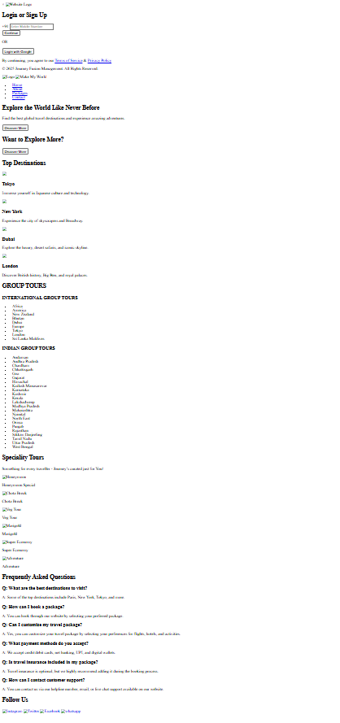

**CODE PACKAGE HTML:-**

<!DOCTYPE html>

<html lang="en">

<head>

<meta charset="UTF-8">

<meta name="viewport" content="width=device-width, initial-scale=1.0">

<title>Travel Packages</title>

</head>

<body>

<header>

<h1> Packages</h1>

</header>

<section class="packages-container">

<!-- International Tours Section -->

<div class="package-column">

<h2>International Tours</h2>

<div class="packages">

<div class="package-card">

<img src="image\london.jpg" alt="London">

<h3>London</h3>

<p>Explore London’s history and culture.</p>

<p class="price">$1500</p>

<a href="booking.html" class="btn">Book Now</a>

</div>

<div class="package-card">

<img src="image\tokyo.jpg" alt="Tokyo">

<h3>Tokyo</h3>

<p>Visit Japan’s iconic city with amazing food.</p>

<p class="price">$1800</p>

<a href="booking.html" class="btn">Book Now</a>

</div>

<div class="package-card">

<img src="image\paris.jpg" alt="Paris">

<h3>Paris</h3>

<p>Enjoy the romantic city of Paris.</p>

<p class="price">$1700</p>

<a href="booking.html" class="btn">Book Now</a>

</div>

<div class="package-card">

<img src="image\newyork.jpg" alt="New York">

<h3>New York</h3>

<p>Discover the city that never sleeps!</p>

<p class="price">$2000</p>

<a href="booking.html" class="btn">Book Now</a>

</div>

<div class="package-card">

<img src="image\dubai.jpg" alt="Dubai">

<h3>Dubai</h3>

<p>Experience the luxury of Dubai.</p>

<p class="price">$2500</p>

<a href="booking.html" class="btn">Book Now</a>

</div>

<div class="package-card">

<img src="image\sydney.jpg" alt="Sydney">

<h3>Sydney</h3>

<p>Enjoy the scenic beauty of Sydney.</p>

<p class="price">$2200</p>

<a href="booking.html" class="btn">Book Now</a>

</div>

<div class="package-card">

<img src="image\rome.jpg" alt="Rome">

<h3>Rome</h3>

<p>Travel back in time with Rome.</p>

<p class="price">$1900</p>

<a href="booking.html" class="btn">Book Now</a>

</div>

<div class="package-card">

<img src="image\bangkok.jpg" alt="Bangkok">

<h3>Bangkok</h3>

<p>Discover the vibrant street life of Bangkok.</p>

<p class="price">$1400</p>

<a href="booking.html" class="btn">Book Now</a>

</div>

<div class="package-card">

<img src="image\singapore.jpg" alt="Singapore">

<h3>Singapore</h3>

<p>Enjoy the futuristic city of Singapore.</p>

<p class="price">$2100</p>

<a href="booking.html" class="btn">Book Now</a>

</div>

<!-- Add more international tour packages here (Total 20) -->

</div>

</div>

<!-- 🇮🇳 Indian Tours Section -->

<div class="package-column">

<h2>Indian Tours</h2>

<div class="packages">

<div class="package-card">

<img src="image\goa.jpg" alt="Goa">

<h3>Goa</h3>

<p>Relax on the sunny beaches of Goa.</p>

<p class="price">₹20,000</p>

<a href="booking.html" class="btn">Book Now</a>

</div>

<div class="package-card">

<img src="image\manali.jpg" alt="Manali">

<h3>Manali</h3>

<p>Enjoy the snowy mountains of Himachal.</p>

<p class="price">₹25,000</p>

<a href="booking.html" class="btn">Book Now</a>

</div>

<div class="package-card">

<img src="image\kerala.jpg" alt="Kerala">

<h3>Kerala</h3>

<p>Experience the backwaters of Kerala.</p>

<p class="price">₹30,000</p>

<a href="booking.html" class="btn">Book Now</a>

</div>

<div class="package-card">

<img src="image\jaipur.jpg" alt="Jaipur">

<h3>Jaipur</h3>

<p>Discover the heritage of Rajasthan.</p>

<p class="price">₹28,000</p>

<a href="booking.html" class="btn">Book Now</a>

</div>

<div class="package-card">

<img src="image\leh.jpg" alt="Leh-Ladakh">

<h3>Leh-Ladakh</h3>

<p>Explore the breathtaking landscapes of Ladakh.</p>

<p class="price">₹35,000</p>

<a href="booking.html" class="btn">Book Now</a>

</div>

<div class="package-card">

<img src="image\kashmir.jpg" alt="Kashmir">

<h3>Kashmir</h3>

<p>Enjoy the paradise on Earth.</p>

<p class="price">₹40,000</p>

<a href="booking.html" class="btn">Book Now</a>

</div>

<div class="package-card">

<img src="image\ooty.jpg" alt="Ooty">

<h3>Ooty</h3>

<p>Experience the Queen of Hill Stations.</p>

<p class="price">₹18,000</p>

<a href="booking.html" class="btn">Book Now</a>

</div>

<div class="package-card">

<img src="image\andaman.jpg" alt="Andaman">

<h3>Andaman</h3>

<p>Enjoy the crystal clear beaches.</p>

<p class="price">₹50,000</p>

<a href="booking.html" class="btn">Book Now</a>

</div>

<!-- Add more Indian tour packages here (Total 20) -->

</div>

</div>

</section>

</body>

</html>

**OUTPUT**

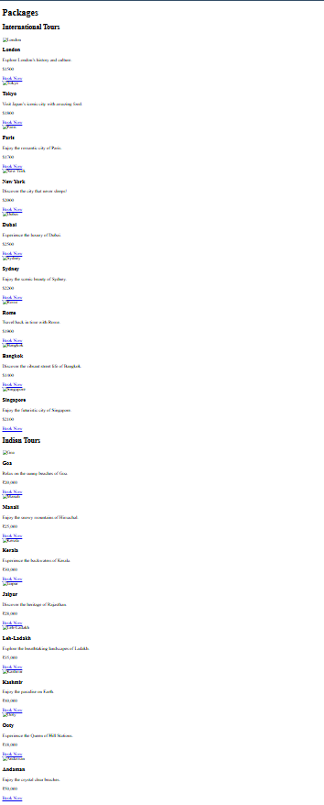

**CODE ABOUT HTML:-**

<!DOCTYPE html>

<html lang="en">

<head>

<meta charset="UTF-8">

<meta name="viewport" content="width=device-width, initial-scale=1.0">

<title>About Us - Journey Fusion</title>

</head>

<body>

<!-- Navigation Bar -->

<nav>

<div class="logo">Journey Fusion</div>

<ul class="nav-links">

<li><a href="index.html">Home</a></li>

<li><a href="about.html" class="active">About</a></li>

<li><a href="contact.html">Contact</a></li>

<li><a href="packages.html">Packages</a></li>

</ul>

</nav>

<!-- About Us Section -->

<section class="about">

<div class="container">

<h1>About Us</h1>

<p>Welcome to Journey Fusion! We are passionate about bringing you the best travel experiences across the globe.</p>

<div class="about-content">

<img src="https://hdqwalls.com/wallpapers/long-journey-f2" alt="Our Journey">

<div class="text">

<h2>Our Mission</h2>

<p>We aim to make travel easier, affordable, and more exciting for everyone. With our carefully curated packages, we ensure you have a seamless and enjoyable journey.</p>

<h2>Why Choose Us?</h2>

<ul>

<li>🏝️ Handpicked destinations</li>

<li>💰 Affordable pricing</li>

<li>📞 24/7 customer support</li>

<li>🎉 Exciting travel experiences</li>

</ul>

</div>

</div>

</div>

</section>

<!-- Our Vision Section -->

<section class="vision">

<div class="container">

<h2>Our Vision</h2>

<p>To revolutionize the way people travel by offering personalized, high-quality, and seamless travel experiences tailored to individual needs.</p>

</div>

</section>

<!-- Our Values Section -->

<section class="values">

<div class="container">

<h2>Our Values</h2>

<div class="values-list">

<div class="value-item">

<h3>🌍 Sustainability</h3>

<p>We prioritize eco-friendly travel experiences and encourage responsible tourism.</p>

</div>

<div class="value-item">

<h3>🤝 Integrity</h3>

<p>Transparency and trust are at the core of our business. We ensure honesty in all our dealings.</p>

</div>

<div class="value-item">

<h3>🎯 Customer Focus</h3>

<p>Our customers are our priority. We strive to provide the best service and travel experiences.</p>

</div>

</div>

</div>

</section>

<!-- Our Services Section -->

<section class="services">

<div class="container">

<h2>Our Services</h2>

<div class="service-list">

<div class="service-item">

<h3>✈️ Flight Bookings</h3>

<p>We help you find the best deals on domestic and international flights.</p>

</div>

<div class="service-item">

<h3>🏨 Hotel Reservations</h3>

<p>Enjoy a comfortable stay with our carefully selected hotels and resorts.</p>

</div>

<div class="service-item">

<h3>🚗 Travel Assistance</h3>

<p>24/7 support to make your travel smooth and hassle-free.</p>

</div>

<div class="service-item">

<h3>🗺️ Custom Tour Packages</h3>

<p>Personalized travel itineraries tailored to your preferences.</p>

</div>

</div>

</div>

</section>

</body>

</html>

**OUTPUT**

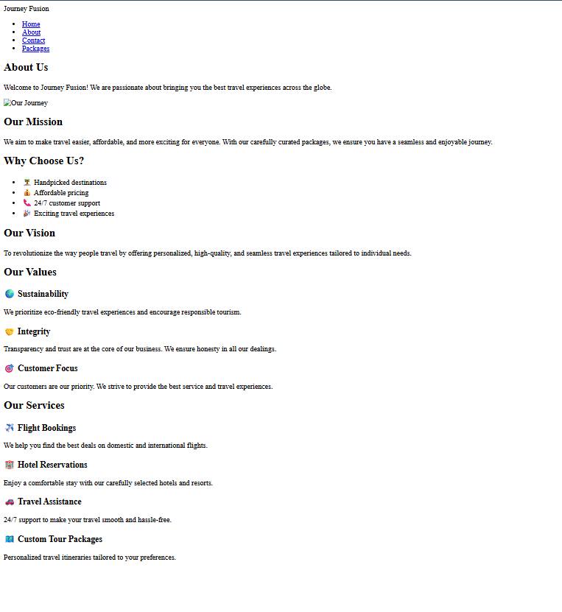

**CODE CONTACT HTML**

<!DOCTYPE html>

<html lang="en">

<head>

<meta charset="UTF-8">

<meta name="viewport" content="width=device-width, initial-scale=1.0">

<title>Contact Us</title>

</head>

<body>

<!-- Navigation Bar -->

<nav>

<div class="logo">Journey Fusion</div>

<ul class="nav-links">

<li><a href="index.html">Home</a></li>

<li><a href="about.html">About</a></li>

<li><a href="contact.html" class="active">Contact</a></li>

<li><a href="packages.html">Packages</a></li>

</ul>

</nav>

<!-- Contact Section -->

<section class="contact">

<div class="container">

<h1>Contact Us</h1>

<p>Have any questions or inquiries? Feel free to reach out to us.</p>

<div class="contact-content">

<!-- Contact Form -->

<form>

<label for="name">Full Name</label>

<input type="text" id="name" placeholder="Enter your name" required>

<label for="email">Email</label>

<input type="email" id="email" placeholder="Enter your email" required>

<label for="message">Message</label>

<textarea id="message" placeholder="Type your message here..." required></textarea>

<button type="submit">Send Message</button>

</form>

<!-- Contact Info -->

<div class="contact-info">

<h2>Get in Touch</h2>

<p>📍 Address: 123 Travel Street, City, Country</p>

<p>📞 Phone: +123 456 7890</p>

<p>📧 Email: support@journeyfusion.com</p>

<p>🌍 Website: www.journeyfusion.com</p>

</div>

</div>

</div>

</section>

</body>

</html>

**OUTPUT**

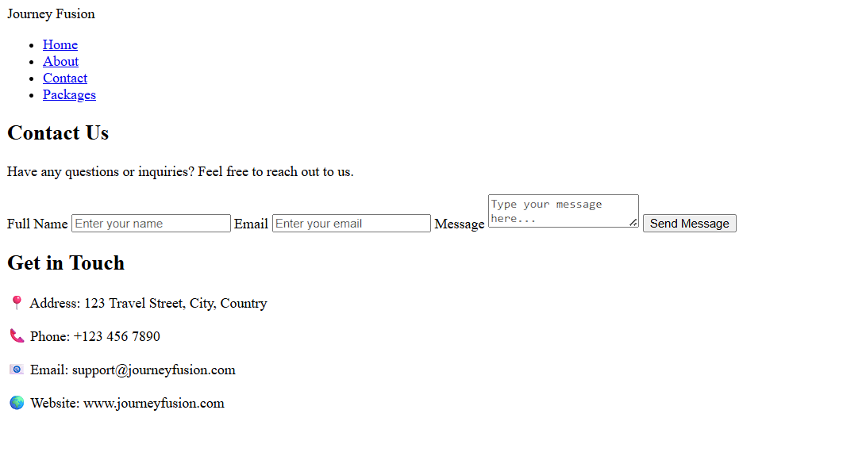

**Conclusion**

The use of **CSS Grid** in the Tourism Management Website significantly improves the overall layout, structure, and user experience. By leveraging the two-dimensional power of CSS Grid, the homepage and destination listings are presented in a **clean, responsive, and organized manner**. It allows for better alignment of content such as images, headings, summaries, and buttons, making the website visually appealing and easy to navigate on all devices.

With CSS Grid, the website becomes **scalable**, **maintainable**, and **mobile-friendly**, ensuring that both desktop and mobile users can explore travel packages and destinations seamlessly. This modern layout technique contributes to a **professional and engaging travel platform**, aligning well with user expectations in today’s web standards.

**Experiment No.3**

**Problem Statement**  
Enhance the layout of the **Tourism Management Website** homepage using **CSS Grid**. Use CSS Grid to structure tourism destination listings and organize sections like banners, packages, categories, images, descriptions, and call-to-action buttons.

#### Introduction to CSS Grid

CSS Grid Layout is a powerful two-dimensional layout system used in web design. It allows developers to create complex, responsive website layouts that adjust to both **rows and columns**. Unlike Flexbox (which is one-directional), CSS Grid is ideal for **structured content like a tourism website**, where destinations, packages, and images must be aligned neatly.

#### Why CSS Grid for Tourism Website?

A tourism platform requires an appealing, organized, and mobile-friendly layout. CSS Grid helps by:

* Creating responsive layouts for destination or package cards.
* Organizing sections like **"Top Destinations"**, **"Featured Packages"**, or **"Travel Categories"**.
* Ensuring consistency in alignment of images, headings, descriptions, and pricing.
* Providing a clean, professional view on both mobile and desktop devices.

### Homepage Layout with CSS Grid

The homepage includes:

* A **full-width navigation bar** with links to Home, Packages, Contact, etc.
* A **hero section** with a banner and an "Explore Now" button.
* A **grid layout for destinations/packages** showing images, descriptions, and booking links.
* A **testimonials section** in a horizontal row.
* A **footer** with contact details and social media icons.

**Benefits:**

* Structured and neat layout for better user experience.
* Easy to add more destinations or packages without breaking layout.
* Responsive design looks great on all devices.

### Destination/Package Listing Using CSS Grid

Each tourism card includes:

* A destination image.
* A title (e.g., “Explore Paris”).
* A short description or summary.
* Price and travel duration.
* A **“Book Now”** or **“View More”** button.

### Additional Styling Concepts

* **Section Headings**: Large fonts and background color for clarity.
* **Section Separators**: Borders or horizontal lines for visual division.
* **Hover Effects**: Add zoom, shadow, or color change on cards or buttons.
* **Responsive Design**: Use auto-fit and minmax() for flexibility on small screens.

### Mobile Responsiveness with CSS Grid

CSS Grid adapts well to smaller screens:

* Adjusts to **1–2 columns** on mobile devices.
* Maintains readability with proper spacing.
* Provides a fast and pleasant mobile browsing experience.

### Key Features of CSS Used

* **Styling**: Colors, fonts, shadows, paddings, and borders.
* **Layout Control**: Grid and Flexbox for structured sections.
* **Responsive Design**: Media queries and grid auto-sizing.
* **Maintainability**: CSS classes reused across multiple pages.
* **Dark Mode (Optional)**: Add support for dark mode using variables.

### CSS Selectors Recap

* element – Select by tag (h1, div, img)
* .class – Select by class name (.package-card)
* #id – Select by ID (#header)
* * – Universal selector (all elements)
* a:hover, ul li, div > p – Nested or interactive selectors

### CSS Box Model

Each element is made of:

* **Content** – Image/text inside.
* **Padding** – Space around content.
* **Border** – Outline of the box.
* **Margin** – Space outside the box.

### Advanced CSS Features Used

| **Feature** | **Description** |
| --- | --- |
| Flexbox | One-dimensional row/column layout |
| Grid | Two-dimensional page layout |
| Animations | Transitions on buttons or cards |
| Variables | Theme customization (--primary-color) |
| Media Queries | Responsive design for all devices |

### CSS in Tourism Platform

In this project:

* CSS creates a modern, user-friendly tourism experience.
* Grid layout shows destinations and packages clearly.
* Hover and animation effects enhance interactivity.
* Responsive layout adapts to mobile, tablet, and desktop screens.

**CODE CSS**

/* Google Fonts */

@import url('https://fonts.googleapis.com/css2?family=Playfair+Display:wght@400;600&family=Poppins:wght@300;400;600&display=swap');

* {

margin: 0;

padding: 0;

box-sizing: border-box;

font-family: 'Poppins', sans-serif;

scroll-behavior: smooth;

}

body {

background-color: transparent;

color: #0f0101;

}

/* Navbar सुधारणा */

.navbar {

display: flex;

justify-content: space-between;

align-items: center;

background:transparent;

padding: 15px 50px;

position: fixed;

width: 100%;

top: 0;

z-index: 1000;

backdrop-filter: none;

box-shadow: none;

border:none;

}

.navbar a {

background: linear-gradient(90deg, #ff8008, #ffc837);

color: #fff;

border-radius: 30px; /* Rounded edges */

text-decoration: none; /* No underline */

font-weight: bold;

transition: 0.3s ease-in-out;

padding: 12px 30px;

font-size: 18px;

border: none;

cursor: pointer;

box-shadow: 0px 5px 15px rgba(0, 0, 0, 0.3);

letter-spacing: 1px;

}

.navbar a:hover {

transform: scale(1.1);

box-shadow: 0px 8px 20px rgba(0, 0, 0, 0.4);

}

/* लोगो आणि टेक्स्ट एका रेषेत आणि व्यवस्थित */

.logo-container {

display: flex;

align-items: center;

gap: 10px;

}

/* Logo icon */

.logo-icon {

width: 50px;

height: 50px;

filter: invert(1);

}

/* Brand image (letter.png) */

.brand-image {

width: 100px;

height: 50px;

}

/* Navigation Links */

.nav-links {

display: flex;

gap: 25px;

list-style: none;

}

.nav-links a {

text-decoration: none;

color: white;

font-weight: bold;

font-size: 18px;

transition: color 0.3s;

}

.nav-links a:hover {

color: #e4e4e2;

}

/* Hero Section */

.hero {

height: 100vh;

background-size: 400% 400%;

animation: gradientBG 8s infinite alternate;

display: flex;

align-items: center;

justify-content: center;

text-align: center;

color: white;

position: relative;

}

.hero h1 {

font-size: 50px;

font-family: 'Playfair Display', serif;

margin-bottom: 10px;

text-shadow: 2px 2px 10px rgba(0, 0, 0, 0.3);

}

.hero p {

font-size: 22px;

margin-bottom: 20px;

}

.btn {

padding: 12px 30px;

font-size: 18px;

font-weight: bold;

background: linear-gradient(90deg, #ff8008, #ffc837);

border: none;

cursor: pointer;

transition: 0.3s ease-in-out;

border-radius: 30px;

color: #fff;

box-shadow: 0px 5px 15px rgba(0, 0, 0, 0.3);

letter-spacing: 1px;

}

.btn:hover {

transform: scale(1.1);

box-shadow: 0px 8px 20px rgba(0, 0, 0, 0.4);

}

/* Top Destinations */

.top-destinations {

text-align: center;

margin-top: 100px;

padding: 60px;

background: white;

animation: fadeInUp 1.5s ease-in-out;

}

.top-destinations h2 {

font-size: 36px;

margin-bottom: 30px;

font-family: 'Playfair Display', serif;

}

.destination-container {

display: flex;

justify-content: center;

gap: 20px;

flex-wrap: wrap;

}

.destination-card {

background: white;

width: 270px;

border-radius: 15px;

overflow: hidden;

box-shadow: 0 5px 15px rgba(0, 0, 0, 0.15);

transition: transform 0.3s ease-in-out, box-shadow 0.3s;

}

.destination-card:hover {

transform: translateY(-10px);

box-shadow: 0 8px 25px rgba(0, 0, 0, 0.3);

}

.destination-card img {

width: 100%;

height: 200px;

object-fit: cover;

transition: transform 0.3s;

}

.destination-card:hover img {

transform: scale(1.05);

}

.destination-card h3 {

font-size: 22px;

margin: 15px 0;

font-family: 'Playfair Display', serif;

}

.destination-card p {

font-size: 16px;

padding: 0 15px 20px;

color: gray;

}

/* Animations */

@keyframes fadeInUp {

from {

opacity: 0;

transform: translateY(30px);

}

to {

opacity: 1;

transform: translateY(0);

}

}

@keyframes slideDown {

from {

transform: translateY(-100%);

}

to {

transform: translateY(0);

}

}

@keyframes gradientBG {

0% {

background-position: 0% 50%;

}

100% {

background-position: 100% 50%;

}

}

/* Popup Background */

.login-popup {

display: none;

position: fixed;

top: 0;

left: 0;

width: 100%;

height: 100%;

background: rgba(0, 0, 0, 0.6);

justify-content: center;

align-items: center;

backdrop-filter: blur(5px);

z-index: 2000;

}

/* Popup Box */

.popup-content {

animation: bgAnimation 8s infinite linear; /* 8 seconds loop */

transition: background 1s ease-in-out;

width: 400px;

padding: 20px;

background: #1e3c72;

border-radius: 12px;

box-shadow: 0 10px 25px rgba(0, 0, 0, 0.3);

position: relative;

border: 3px solid transparent;

background-clip: padding-box;

}

/* Gradient Border */

.popup-content::before {

content: "";

position: absolute;

top: -4px;

left: -4px;

right: -4px;

bottom: -4px;

background: linear-gradient(45deg, #007bff, #ff00ff);

border-radius: 15px;

z-index: -1;

}

/* Left Side Content */

.popup-main {

flex: 1;

padding: 20px;

text-align: center;

}

/* Close Button */

.close-btn {

position: absolute;

top: 10px;

right: 15px;

font-size: 22px;

cursor: pointer;

color: #333;

}

/* Logo */

.popup-logo {

width: 110px;

margin: 0 auto 15px;

}

/* Mobile Input Section */

.mobile-input {

display: flex;

align-items: center;

justify-content: center;

gap: 5px;

margin-bottom: 10px;

}

.country-code {

background: #f4f4f4;

padding: 10px;

border-radius: 8px;

font-size: 16px;

font-weight: bold;

border: 1px solid #ccc;

}

.input-box {

width: 100%;

padding: 10px;

border: 1px solid #ccc;

border-radius: 8px;

font-size: 16px;

}

/* Continue Button */

.popup-content button {

width: 100%;

padding: 12px;

background: linear-gradient(45deg, #007bff, #00c6ff);

color: white;

border: none;

border-radius: 8px;

cursor: pointer;

font-size: 18px;

transition: 0.3s;

}

.popup-content button:hover {

background: linear-gradient(45deg, #005ecb, #0096d6);

}

/* Google Login */

.google-login {

background: white;

color: black;

border: 1px solid #ccc;

padding: 12px;

width: 100%;

font-size: 16px;

display: flex;

align-items: center;

justify-content: center;

cursor: pointer;

transition: 0.3s;

border-radius: 8px;

}

.google-login:hover {

background: #f4f4f4;

}

/* Slide-In Animation */

@keyframes slideIn {

from {

transform: translateY(-50px);

opacity: 0;

}

to {

transform: translateY(0);

opacity: 1;

}

}

@keyframes bgAnimation {

0% { background: #1e3c72; }

25% { background: #2a5298; }

50% { background: #00c6ff; }

75% { background: #0072ff; }

100% { background: #1e3c72; }

}

/* FAQ Section Styling */

#faq {

background: rgba(255, 255, 255, 0.1);

backdrop-filter: blur(10px);

-webkit-backdrop-filter: blur(10px);

padding: 40px;

border-radius: 10px;

box-shadow: 0 4px 10px rgba(0, 0, 0, 0.1);

text-align: center;

margin: 30px 0;

}

/* Heading */

#faq h2 {

font-size: 2.5rem;

color: white;

margin-bottom: 20px;

text-transform: uppercase;

letter-spacing: 2px;

}

.faq-item {

background: rgba(255, 255, 255, 0.2);

backdrop-filter: blur(5px);

padding: 15px;

margin: 10px auto;

border-radius: 8px;

transition: transform 0.3s ease-in-out;

}

/* FAQ Hover Effect */

.faq-item:hover {

transform: scale(1.02);

}

/* Question Styling */

.faq-item h3 {

font-size: 1.4rem;

margin: 0;

padding: 10px 0;

position: relative;

font-weight: bold;

}

/* Answer Styling */

.faq-item p {

font-size: 1rem;

margin: 10px 0 0;

line-height: 1.6;

display: none; /* Initially Hidden */

}

/* Expand/Collapse Animation */

.faq-item.active p {

display: block;

}

/* Responsive Design */

@media (max-width: 768px) {

#faq {

padding: 40px 5%;

}

#faq h2 {

font-size: 2rem;

}

.faq-item h3 {

font-size: 1.2rem;

}

.faq-item p {

font-size: 0.95rem;

}

}

/* Social Media Section */

#social-media {

text-align: center;

padding: 40px 0;

background: rgba(0, 123, 255, 0.1); /* Light Blue Blur */

backdrop-filter: blur(15px);

-webkit-backdrop-filter: blur(15px);

border-radius: 10px;

box-shadow: 0 4px 10px rgba(0, 0, 0, 0.1);

margin: 30px auto;

width: 60%; /* Center Width */

}

/* Follow Us Heading */

#social-media h2 {

font-size: 2.5rem;

color: white;

margin-bottom: 20px;

text-transform: uppercase;

letter-spacing: 2px;

}

/* Social Media Icons - Horizontal Alignment */

.social-icons {

display: flex;

justify-content: center; /* Center horizontally */

align-items: center;

gap: 20px; /* Space between icons */

flex-wrap: nowrap; /* Prevent wrapping */

}

/* Social Media Icons */

#social-media a {

display: inline-block;

transition: transform 0.3s ease, opacity 0.3s ease;

}

#social-media img {

width: 50px;

height: 50px;

border-radius: 50%;

border: 2px solid white;

padding: 5px;

background: white;

transition: all 0.3s ease-in-out;

}

#social-media a:hover {

transform: scale(1.2);

opacity: 0.8;

}

/* Responsive Design */

@media (max-width: 768px) {

#social-media {

width: 80%;

}

#social-media h2 {

font-size: 2rem;

}

.social-icons {

gap: 15px;

}

#social-media img {

width: 40px;

height: 40px;

}

}

#bgSlider {

position: fixed;

top: 0;

left: 0;

width: 100%;

height: 100vh;

background-size: cover;

background-position: center;

animation: bgChange 15s infinite alternate;

z-index: -10;

}

@keyframes bgChange {

0% { background-image: url('image/image1.jpg'); }

10% { background-image: url('image/image2.jpg'); }

20% { background-image: url('image/image3.jpg');}

30% { background-image: url('image/image4.jpg'); }

40% { background-image: url('image/image5.jpg'); }

50% { background-image: url('image/image6.jpg'); }

60% { background-image: url('image/image7.jpg'); }

70% { background-image: url('image/image8.jpg'); }

80% { background-image: url('image/image9.jpg');}

90% { background-image: url('image/image10.jpg');}

}

/* Speciality Tours Section */

#speciality-tours {

text-align: center;

padding: 50px 0;

background: rgba(0, 0, 255, 0.05); /* Light Blue Transparent Background */

backdrop-filter: blur(10px);

-webkit-backdrop-filter: blur(10px);

border-radius: 10px;

margin: 40px auto;

width: 90%;

}

#speciality-tours h2 {

font-size: 2.8rem;

font-weight: bold;

color: #222;

margin-bottom: 10px;

text-transform: uppercase;

}

#speciality-tours p {

font-size: 1.4rem;

color: #555;

margin-bottom: 30px;

}

/* Tour Cards */

.tour-container {

display: flex;

justify-content: center;

gap: 20px;

flex-wrap: wrap;

}

.tour-card {

position: relative;

width: 250px;

height: 280px;

border-radius: 15px;

overflow: hidden;

box-shadow: 0 8px 16px rgba(0, 0, 0, 0.1);

transition: transform 0.3s ease-in-out, box-shadow 0.3s ease-in-out;

cursor: pointer;

}

.tour-card img {

width: 100%;

height: 100%;

object-fit: cover;

border-radius: 15px;

transition: transform 0.3s ease-in-out;

}

.tour-card p {

position: absolute;

bottom: 0;

width: 100%;

background: rgba(0, 0, 0, 0.7);

color: white;

font-size: 1.1rem;

text-align: center;

padding: 12px;

font-weight: bold;

text-transform: uppercase;

border-radius: 0 0 15px 15px;

white-space: nowrap; /* Prevent text from wrapping */

overflow: hidden;

text-overflow: ellipsis; /* Add '...' if text is too long */

max-width: 100%; /* Ensure it fits inside the card */

}

/* Hover Effects */

.tour-card:hover {

transform: scale(1.05);

box-shadow: 0 12px 24px rgba(0, 0, 0, 0.2);

}

.tour-card:hover img {

transform: scale(1.1);

}

.group-tours {

text-align: center;

padding: 80px 0;

background: linear-gradient(to bottom, rgba(0, 0, 0, 0.6), rgba(0, 0, 0, 0.6)),

url('your-background-image.jpg') center/cover no-repeat;

color: white;

}

.group-tours h2 {

font-size: 2.8rem;

font-weight: bold;

text-transform: uppercase;

margin-bottom: 30px;

letter-spacing: 2px;

font-family: 'Poppins', sans-serif;

}

.tour-container {

display: flex;

justify-content: center;

flex-wrap: wrap;

max-width: 1200px;

margin: auto;

gap: 50px;

}

.tour-category {

flex: 1;

min-width: 350px;

text-align: left;

padding: 25px;

background: rgba(255, 255, 255, 0.1);

border-radius: 15px;

backdrop-filter: blur(10px);

box-shadow: 0 10px 25px rgba(0, 0, 0, 0.3);

transition: transform 0.3s ease-in-out;

}

.tour-category:hover {

transform: translateY(-10px);

}

.tour-category h3 {

font-size: 1.8rem;

font-weight: bold;

border-bottom: 2px solid white;

padding-bottom: 8px;

margin-bottom: 15px;

text-transform: uppercase;

font-family: 'Poppins', sans-serif;

}

.tour-list {

display: flex;

flex-wrap: wrap;

gap: 12px;

}

.tour-list span {

font-size: 1.3rem;

font-weight: 500;

background: rgba(255, 255, 255, 0.2);

padding: 10px 20px;

border-radius: 20px;

transition: all 0.3s ease-in-out;

cursor: pointer;

font-family: 'Poppins', sans-serif;

position: relative;

color: white;

overflow: hidden;

}

/* Animation Effect on Hover */

.tour-list span::before {

content: '';

position: absolute;

left: -100%;

top: 0;

width: 100%;

height: 100%;

background: rgba(255, 255, 255, 0.3);

transition: all 0.3s ease-in-out;

}

.tour-list span:hover::before {

left: 0;

}

.tour-list span:hover {

background: rgba(255, 255, 255, 0.5);

color: black;

transform: scale(1.1);

}

/* General Styles */

body {

font-family: 'Poppins', sans-serif;

background: linear-gradient(-45deg, #f8f9fa, #2a96e4, #383e47, #b5c6e0);

background-size: 400% 400%;

animation: gradientBG 6s ease infinite;

margin: 0;

padding: 0;

}

/* Background Animation */

@keyframes gradientBG {

0% { background-position: 0% 50%; }

50% { background-position: 100% 50%; }

100% { background-position: 0% 50%; }

}

/* Header - Packages */

header {

text-align: center;

padding: 25px;

background: linear-gradient(90deg, #007BFF, #0056b3);

color: white;

font-size: 36px;

font-weight: bold;

text-transform: uppercase;

letter-spacing: 2px;

font-family: 'Playfair Display', serif;

border-radius: 10px;

width: 80%;

margin: 30px auto;

box-shadow: 0px 8px 16px rgba(0, 0, 0, 0.2);

}

.section-title {

text-align: center;

font-size: 28px;

font-weight: bold;

display: flex;

justify-content: center;

align-items: center;

text-transform: uppercase;

color: #333;

font-family: 'Montserrat', sans-serif;

margin: 40px auto;

background: linear-gradient(90deg, #007BFF, #FF5733);

-webkit-background-clip: text; /* For Safari/Chrome */

-moz-background-clip: text; /* For Mozilla Firefox */

background-clip: text; /* Standard Property */

-webkit-text-fill-color: transparent;

}

/* Packages Section */

.packages {

display: grid;

grid-template-columns: repeat(auto-fit, minmax(300px, 1fr));

gap: 20px;

padding: 40px;

justify-content: center;

}

/* Package Card */

.package-card {

background: white;

border-radius: 15px;

box-shadow: 0px 6px 12px rgba(0, 0, 0, 0.1);

overflow: hidden;

text-align: center;

transition: transform 0.3s ease-in-out, box-shadow 0.3s ease-in-out;

position: relative;

}

/* Animation on hover */

.package-card:hover {

transform: scale(1.05);

box-shadow: 0px 10px 20px rgba(0, 0, 0, 0.2);

}

/* Image Styling */

.package-card img {

width: 100%;

height: 220px;

object-fit: cover;

border-bottom: 4px solid #007BFF;

}

/* Title */

.package-card h2 {

font-size: 24px;

font-family: 'Playfair Display', serif;

color: #007BFF;

font-weight: bold;

margin: 15px 0;

text-transform: uppercase;

transition: color 0.3s;

}

/* Title hover effect */

.package-card h2:hover {

color: #FF5733;

}

/* Description */

.package-card p {

font-size: 16px;

font-family: 'Poppins', sans-serif;

color: #555;

padding: 0 15px;

}

/* Price */

.package-card .price {

font-size: 20px;

font-weight: bold;

color: #28a745;

margin: 10px 0;

font-family: 'Montserrat', sans-serif;

}

/* Button */

.package-card .btn {

display: inline-block;

margin: 15px auto;

padding: 12px 25px;

background: linear-gradient(90deg, #007BFF, #0056b3);

color: white;

text-decoration: none;

border-radius: 50px;

font-size: 16px;

font-weight: bold;

text-transform: uppercase;

transition: background 0.3s ease-in-out, transform 0.2s;

letter-spacing: 1px;

box-shadow: 0px 4px 8px rgba(0, 0, 0, 0.2);

}

/* Button hover effect */

.package-card .btn:hover {

background: linear-gradient(90deg, #FF5733, #FF8C00);

transform: scale(1.1);

}

**OUTPUT**

**HOME PAGE**

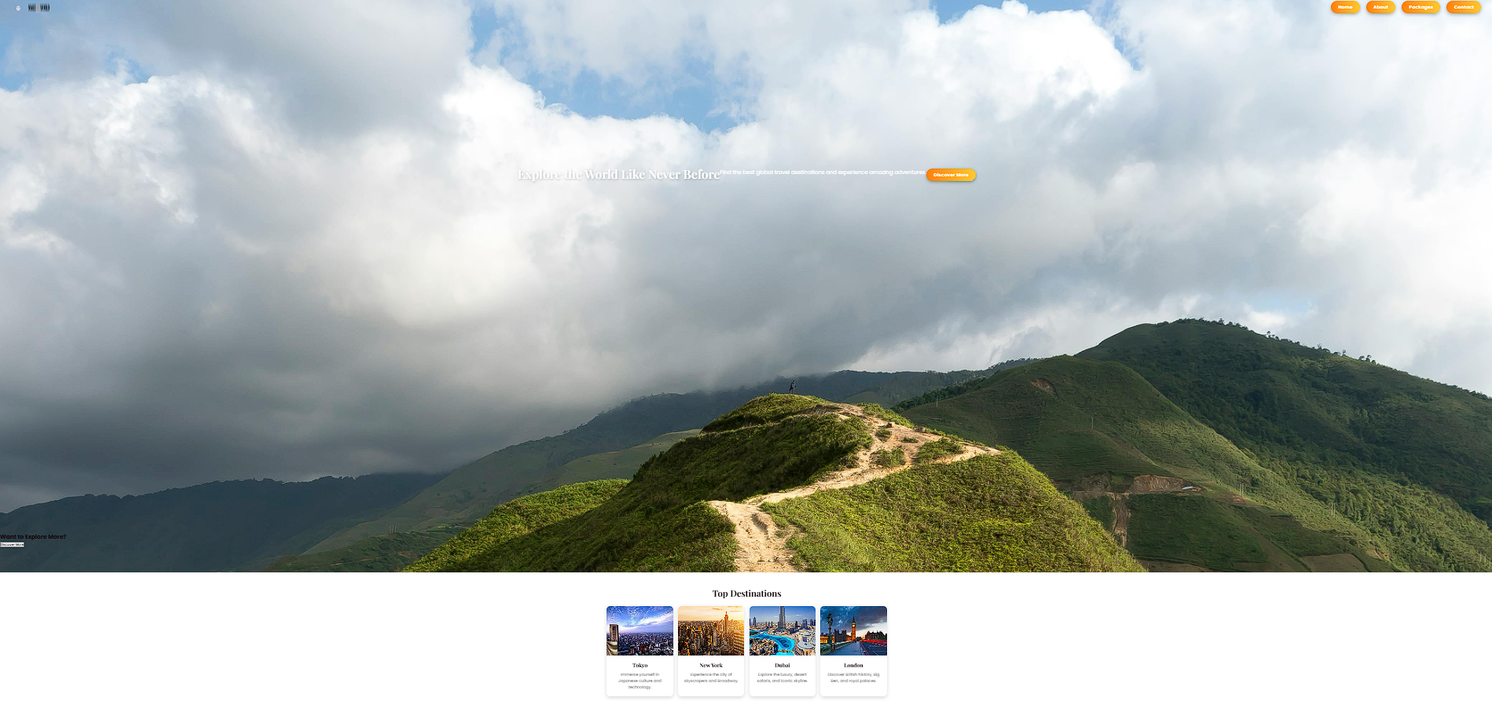

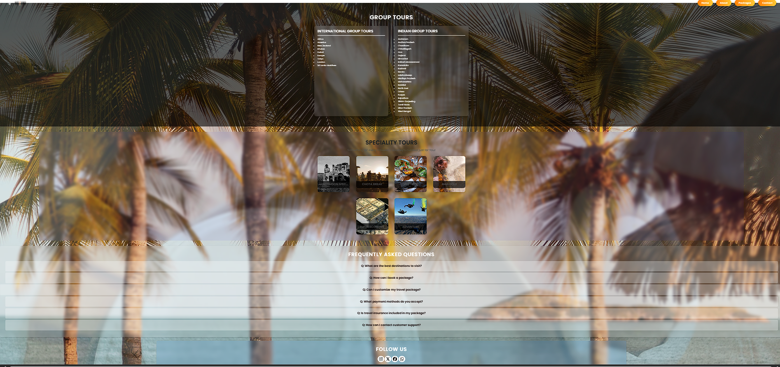

**PACKAGE PAGE**

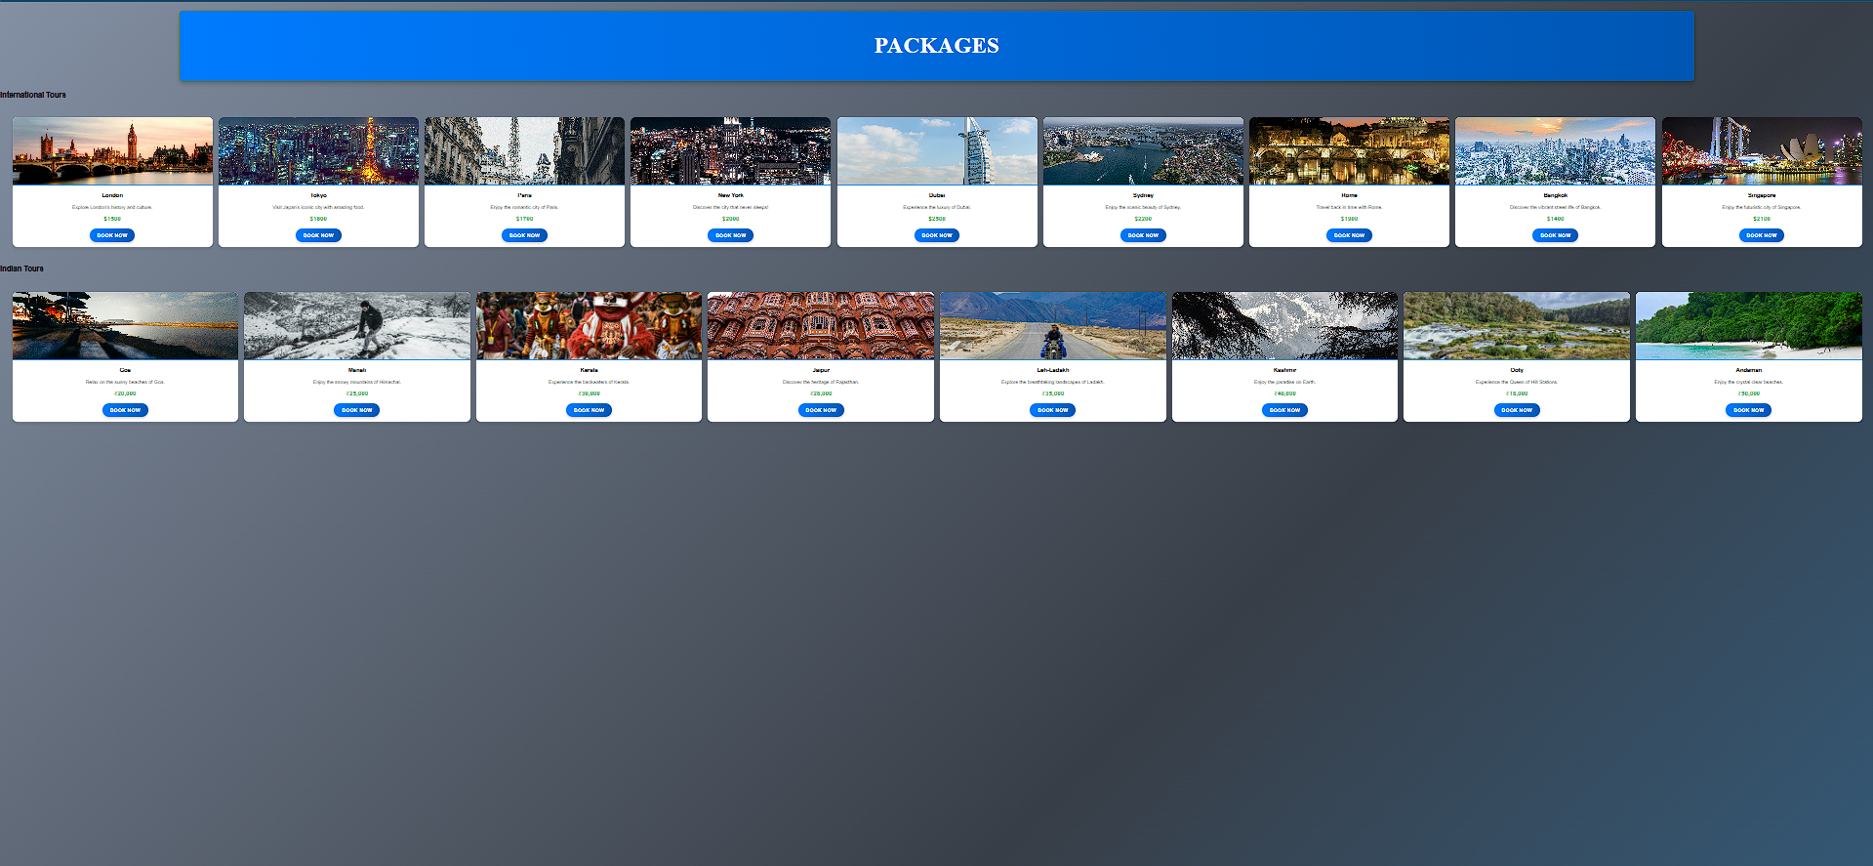

**Conclusion**

The use of **CSS Grid** in the Tourism Management Website significantly improves the overall layout, structure, and user experience. By leveraging the two-dimensional power of CSS Grid, the homepage and destination listings are presented in a **clean, responsive, and organized manner**. It allows for better alignment of content such as images, headings, summaries, and buttons, making the website visually appealing and easy to navigate on all devices.

With CSS Grid, the website becomes **scalable**, **maintainable**, and **mobile-friendly**, ensuring that both desktop and mobile users can explore travel packages and destinations seamlessly. This modern layout technique contributes to a **professional and engaging travel platform**, aligning well with user expectations in today’s web standards.

**Experiment No.4**

### ****Problem Statement: CSS****

A. Enhance the **cart (package booking)** page to make it user-friendly and visually appealing. Style the cart items with appropriate margins, paddings, and input field styles to provide a seamless shopping experience.  
B. Enhance and style the **About Us** page with appropriate margins, paddings, and input field styles.  
C. Enhance and style the **Contact** page to make it user-friendly and visually appealing. Style the contact form with appropriate margins, paddings, and input field styles.  
D. Enhance and style the **admin/user registration form** with appropriate margins, paddings, and input field styles.  
E. Enhance and style the **admin/user login form** with appropriate margins, paddings, and input field styles.

#### 1. Why CSS Styling Matters in Tourism Platforms

First impressions are everything. For a tourism website like **Tourism Management System**, a clean layout, good spacing, and appealing visuals enhance **readability**, **usability**, and **trust**. Whether it's **About**, **Contact**, or **Login/Registration** form, proper CSS styling:

* Improves reading comfort and visual engagement
* Creates clear visual hierarchy and structure
* Enhances user navigation and accessibility
* Increases user trust and boosts bookings

#### 2. About Us Page

This page builds trust by sharing the vision, mission, and team of the tourism agency.

**Key Styling Techniques:**

* Increase line height and padding for paragraph text
* Space out sections like “Our Journey,” “Our Vision,” “Meet the Team”
* Use grid or flexbox to align team member photos in columns
* Round team member images and use hover effects or tooltips
* Style core values using colored sections or quote blocks

**Result:** A professional and inviting layout that builds a strong emotional connection with users.

#### 3. Contact Page

The page allows travelers to send inquiries or suggestions.

**Key Styling Techniques:**

* Equal width and height for all input fields
* Add padding inside input boxes and textareas for ease of typing
* Clearly style form labels, highlight inputs on focus
* Use rounded corners and box shadows on the form
* Center-align the form and apply hover states to the submit button

**Result:** A well-styled and accessible form that encourages users to contact the team with ease.

#### 4. Admin/User Registration Form

Used for new tourists or admin users to register on the platform.

**Key Styling Techniques:**

* Group fields under sections like “Personal Info” and “Account Details”
* Use clear placeholders and visible labels
* Maintain consistent spacing between inputs
* Use light background, shadow effects, and smooth border-radius for the form
* Display validation (e.g., valid email, strong password)

**Result:** A trust-worthy and user-friendly form that enhances the registration experience.

#### 5. Admin/User Login Form

The portal for registered users and administrators to log into the system.

**Key Styling Techniques:**

* Center the login form on the screen
* Provide adequate spacing between email and password fields
* Use clear error messages with color coding (red = error, green = success)
* Apply simple fonts, light box shadows, and clean input field designs
* Include “Show Password” toggle and “Forgot Password?” link

**Result:** A secure and intuitive login interface that builds confidence and quick access for users.

### Code

/* General Styling */

body {

font-family: 'Poppins', sans-serif;

margin: 0;

padding: 0;

background-color: #f0f8ff;

animation: fadeIn 1s ease-in-out;

}

/* Navigation Bar */

nav {

background: #0056b3;

padding: 15px 50px;

display: flex;

justify-content: space-between;

align-items: center;

box-shadow: 0px 4px 8px rgba(0, 0, 0, 0.2);

}

.logo {

font-size: 26px;

font-weight: bold;

color: white;

text-transform: uppercase;

letter-spacing: 2px;

transition: transform 0.3s ease-in-out;

}

.logo:hover {

transform: scale(1.1);

}

.nav-links {

list-style: none;

display: flex;

gap: 20px;

margin: 0;

padding: 0;

}

.nav-links li {

display: inline;

}

.nav-links li a {

text-decoration: none;

color: white;

font-size: 18px;

font-weight: 500;

transition: color 0.3s ease-in-out, transform 0.2s;

}

.nav-links li a:hover {

color: #ffcc00;

transform: scale(1.1);

}

/* About Section */

.about {

text-align: center;

padding: 60px 20px;

}

.about h1 {

font-size: 42px;

color: #0056b3;

font-weight: bold;

text-shadow: 2px 2px 4px rgba(0, 0, 0, 0.2);

animation: fadeIn 1.5s ease-in-out;

}

.about p {

font-size: 18px;

color: #333;

max-width: 800px;

margin: auto;

opacity: 0;

animation: fadeInText 1.5s ease-in-out forwards;

}

/* About Content */

.about-content {

display: flex;

justify-content: center;

align-items: center;

gap: 40px;

margin-top: 30px;

max-width: 1000px;

margin: auto;

opacity: 0;

transform: translateY(30px);

animation: slideUp 1s ease-in-out forwards;

}

.about-content img {

width: 400px;

border-radius: 15px;

box-shadow: 0px 5px 15px rgba(0, 0, 0, 0.2);

transition: transform 0.3s ease-in-out;

}

.about-content img:hover {

transform: scale(1.05);

}

/* Text Box */

.text h2 {

font-size: 30px;

color: #003d80;

position: relative;

display: inline-block;

}

.text h2::after {

content: "";

width: 50%;

height: 3px;

background: #ffcc00;

position: absolute;

left: 50%;

bottom: -5px;

transform: translateX(-50%);

transition: width 0.4s ease-in-out;

}

.text h2:hover::after {

width: 100%;

}

.text ul {

list-style: none;

padding: 0;

}

.text ul li {

font-size: 18px;

color: #333;

margin-bottom: 10px;

position: relative;

left: -10px;

opacity: 0;

animation: fadeInList 1s ease-in-out forwards;

}

/* Vision, Values, and Services Section */

.vision, .values, .services {

text-align: center;

padding: 50px 20px;

background: white;

margin-top: 30px;

opacity: 0;

animation: fadeIn 1.5s ease-in-out forwards;

}

.values-list, .service-list {

display: flex;

justify-content: center;

gap: 30px;

flex-wrap: wrap;

}

.value-item, .service-item {

background: #f0f8ff;

padding: 20px;

border-radius: 10px;

box-shadow: 0px 4px 8px rgba(0, 0, 0, 0.2);

max-width: 300px;

text-align: center;

transition: transform 0.3s ease-in-out, box-shadow 0.3s ease-in-out;

}

.value-item:hover, .service-item:hover {

transform: scale(1.05);

box-shadow: 0px 6px 12px rgba(0, 0, 0, 0.3);

}

.value-item h3, .service-item h3 {

color: #003d80;

}

.value-item p, .service-item p {

font-size: 16px;

color: #555;

}

/* Animations */

@keyframes fadeIn {

from {

opacity: 0;

}

to {

opacity: 1;

}

}

@keyframes fadeInText {

from {

opacity: 0;

transform: translateY(20px);

}

to {

opacity: 1;

transform: translateY(0);

}

}

@keyframes slideUp {

from {

opacity: 0;

transform: translateY(30px);

}

to {

opacity: 1;

transform: translateY(0);

}

}

@keyframes fadeInList {

from {

opacity: 0;

left: -10px;

}

to {

opacity: 1;

left: 0;

}

}

/* Global Styles */

body {

font-family: "Poppins", sans-serif;

margin: 0;

padding: 0;

background-color: #f0f8ff;

}

/* Navigation Bar */

nav {

display: flex;

justify-content: space-between;

align-items: center;

background: #0073e6;

padding: 15px 30px;

color: white;

}

.logo {

font-size: 24px;

font-weight: bold;

}

.nav-links {

list-style: none;

padding: 0;

display: flex;

}

.nav-links li {

margin-left: 20px;

}

.nav-links a {

text-decoration: none;

color: white;

font-size: 18px;

transition: color 0.3s ease;

}

.nav-links a:hover,

.nav-links .active {

color: #ffcc00;

}

/* Contact Section */

.contact {

padding: 60px 20px;

text-align: center;

background-color: #f0f8ff;

}

h1 {

font-size: 36px;

color: #0056b3;

}

p {

font-size: 18px;

color: #555;

}

/* Contact Form & Info */

.contact-content {

display: flex;

justify-content: center;

gap: 40px;

margin-top: 30px;

}

form {

background: white;

padding: 25px;

border-radius: 10px;

box-shadow: 0px 5px 15px rgba(0, 0, 0, 0.2);

width: 400px;

}

form label {

display: block;

font-weight: bold;

margin: 10px 0 5px;

}

form input,

form textarea {

width: 100%;

padding: 10px;

margin-bottom: 15px;

border: 1px solid #ccc;

border-radius: 5px;

}

form textarea {

height: 120px;

}

button {

background: #0073e6;

color: white;

padding: 10px 15px;

border: none;

border-radius: 5px;

font-size: 16px;

cursor: pointer;

transition: background 0.3s ease;

}

button:hover {

background: #005bb5;

}

/* Contact Info */

.contact-info {

background: #fff;

padding: 20px;

border-radius: 10px;

box-shadow: 0px 5px 15px rgba(0, 0, 0, 0.2);

width: 350px;

text-align: left;

}

.contact-info h2 {

font-size: 24px;

color: #003d80;

}

.contact-info p {

font-size: 16px;

color: #333;

margin: 10px 0;

}

/* Responsive Design */

@media (max-width: 768px) {

.contact-content {

flex-direction: column;

align-items: center;

}

form, .contact-info {

width: 90%;

}

}

@import url('https://fonts.googleapis.com/css2?family=Poppins:wght@300;400;600&display=swap');

* {

margin: 0;

padding: 0;

box-sizing: border-box;

font-family: 'Poppins', sans-serif;

}

body {

background: linear-gradient(135deg, #0f0c29, #302b63, #24243e);

display: flex;

justify-content: center;

align-items: center;

height: 100vh;

overflow: hidden;

}

.login-container {

background: rgba(255, 255, 255, 0.1);

padding: 30px;

border-radius: 10px;

box-shadow: 0 8px 16px rgba(0, 0, 0, 0.3);

backdrop-filter: blur(10px);

text-align: center;

color: white;

width: 350px;

animation: fadeIn 1s ease-in-out;

}

h2 {

font-size: 28px;

font-weight: 600;

margin-bottom: 10px;

}

p {

font-size: 14px;

margin-bottom: 20px;

}

input {

width: 100%;

padding: 12px;

margin: 10px 0;

border: none;

outline: none;

border-radius: 5px;

font-size: 16px;

background: rgba(255, 255, 255, 0.2);

color: white;

transition: 0.3s;

}

input::placeholder {

color: rgba(255, 255, 255, 0.7);

}

input:focus {

background: rgba(255, 255, 255, 0.3);

}

button {

width: 100%;

padding: 12px;

margin-top: 10px;

border: none;

border-radius: 5px;

font-size: 16px;

font-weight: bold;

cursor: pointer;

background: #ff416c;

color: white;

transition: 0.3s;

box-shadow: 0 4px 10px rgba(255, 65, 108, 0.3);

}

button:hover {

background: #ff4b2b;

transform: scale(1.05);

}

a {

color: #ff9a9e;

text-decoration: none;

font-weight: bold;

transition: 0.3s;

}

a:hover {

text-decoration: underline;

}

footer {

position: absolute;

bottom: 20px;

font-size: 14px;

color: white;

text-align: center;

width: 100%;

}

@keyframes fadeIn {

from {

opacity: 0;

transform: translateY(-30px);

}

to {

opacity: 1;

transform: translateY(0);

}

}

**Output**

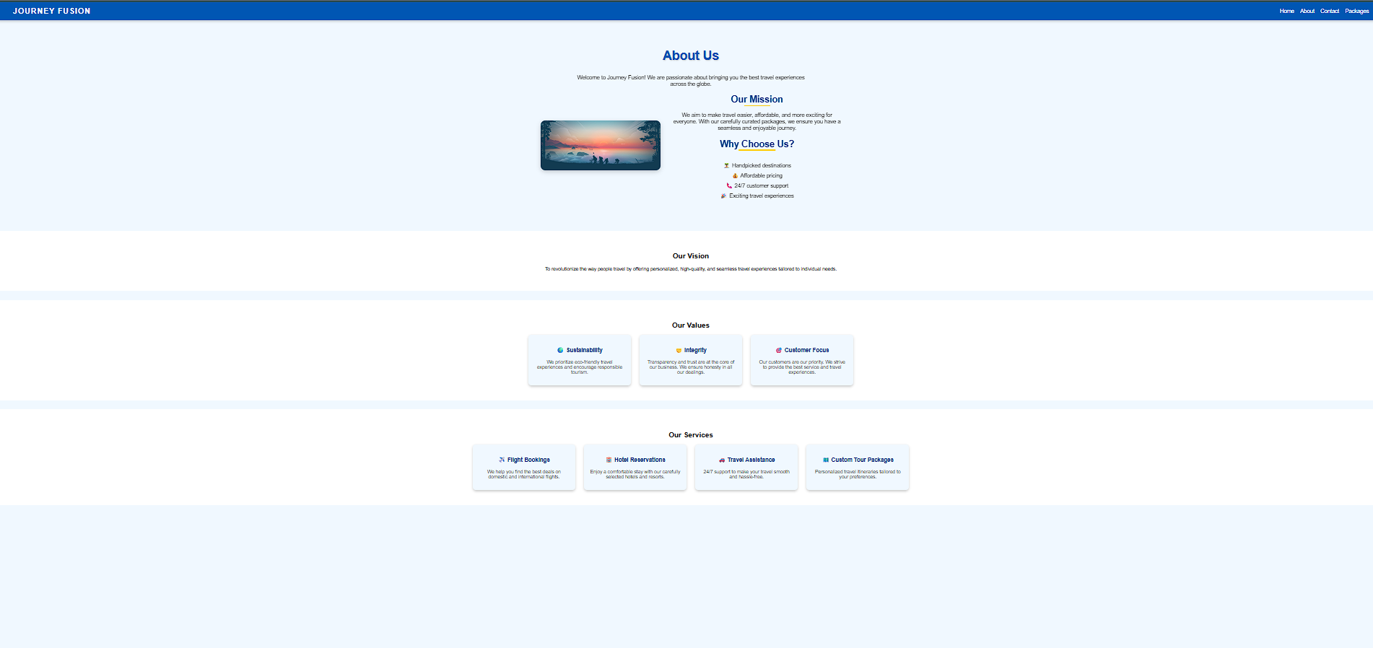

### 

### 

### ****Conclusion****

Through this experiment, we enhanced the visual experience of the **Tourism Management System** website by applying effective **CSS styling** techniques. Pages like **Booked Packages**, **About Us**, **Contact**, **Registration**, and **Login** were redesigned with clean margins, proper paddings, intuitive input fields, and visual elements like shadows and hover effects.

These improvements resulted in:

* A more **professional and engaging design**
* Enhanced **usability** for users and admins
* A layout that builds **trust and clarity**
* Increased **user interaction and satisfaction**

Overall, this experiment helped in making the website more modern, responsive, and aligned with current UI/UX practices for tourism platforms.

**Experiment No. 5**

### ****Problem Statement:****

**A.** Implement user registration and login forms for the **Tourism Management System** website. These forms will allow users to:

* Create an account (e.g., Name, Email, Phone, Password, etc.)
* Log in using their credentials
* Access personalized features such as saving favorite tour packages or viewing booking history.

**User Registration Form** will allow new customers to sign up and create an account on the website. The form will capture basic user details, including the name, email address, phone number, and password (not limited to these fields).

**User Login Form** will allow registered users to log into their accounts. The form will require an email address and a password to authenticate the user.

**B.** Provide validations for user registration and login forms to ensure:

* All required fields are filled
* The email format is valid
* Passwords meet complexity requirements

**C.** Develop **cart functionality** to allow users to:

* Add tour packages to a cart
* Update number of persons
* Remove packages
* View total cost of selected packages

### ****Introduction****

In today's digital world, a **Tourism Management System** like JourneyFusion thrives on user engagement, personalized tour experiences, and a seamless booking interface. JavaScript plays a vital role in client-side interactions like user registration, login, cart management, and form validations—making the platform more dynamic and user-friendly.

### ****Key Features of JavaScript****

* **Lightweight and Fast**
* **Event-driven:** Responds to user actions like button clicks
* **Object-oriented:** Organizes data like user info or cart items
* **First-class functions:** Functions can be treated as variables
* **Asynchronous support:** Handles non-blocking tasks like booking submissions

### ****JavaScript in the Tourism Platform****

In the JourneyFusion tourism platform, JavaScript is used to:

* Handle **theme toggle (e.g., dark/light mode)**
* Enable **interactivity** (e.g., Save to Favourites, Add to Cart)
* Validate and submit the **booking/contact forms**
* Dynamically **update cart and package information**
* Use **AJAX** to send data to backend (Node.js, PHP + MySQL)

### ****JavaScript Core Concepts Used****

| **Concept** | **Description** |
| --- | --- |
| Variables | Store user input like name, email |
| Functions | Logic for validations or toggling UI |
| DOM Manipulation | Access/update HTML elements dynamically |
| Events | Handle clicks, form submissions |
| Loops | Display items in cart |
| Conditions | Validate input or user authentication |
| Arrays/Objects | Store packages, user sessions |
| ES6 Features | Modern syntax like arrow functions, classes |

## ****User Registration and Login Forms****

## ****Registration Form****

Captures: Name, Email, Phone, Password, Confirm Password  
**JavaScript Functions:**

* Ensure fields are not blank
* Validate email with RegEx
* Check password complexity and match
* Show real-time hints

### ****Login Form****

Captures: Email and Password

**JavaScript Functions:**

* Check for empty fields
* Validate credentials (demo/hardcoded or via backend)
* Show error messages
* Redirect on success

## ****2. JavaScript Form Validations****

### ****Common Validations:****

* All fields must be filled
* Email must contain @ and .
* Password must be 6+ characters
* Password and Confirm Password must match
* Live feedback using oninput or onblur events

## ****3. Cart / Tour Package Booking Feature****

Unlike a blogging platform's "Bookmark" system, here users have a **Booking Cart** for tour packages.

### ****Cart Functions:****

* "Add to Cart" for each tour
* Quantity update (number of travelers)
* Total cost calculation
* Remove from cart
* **Local storage to retain cart data across sessions**

**Code**

<!DOCTYPE html>

<html lang="en">

<head>

<meta charset="UTF-8">

<meta name="viewport" content="width=device-width, initial-scale=1.0">

<title>Travel Packages</title>

<link rel="stylesheet" href="package.css">

</head>

<body>

<header>

<h1> Packages</h1>

</header>

<section class="packages-container">

<!-- International Tours Section -->

<div class="package-column">

<h2>International Tours</h2>

<div class="packages">

<div class="package-card">

<img src="image\london.jpg" alt="London">

<h3>London</h3>

<p>Explore London’s history and culture.</p>

<p class="price">$1500</p>

<a href="booking.html" class="btn">Book Now</a>

</div>

<div class="package-card">

<img src="image\tokyo.jpg" alt="Tokyo">

<h3>Tokyo</h3>

<p>Visit Japan’s iconic city with amazing food.</p>

<p class="price">$1800</p>

<a href="booking.html" class="btn">Book Now</a>

</div>

<div class="package-card">

<img src="image\paris.jpg" alt="Paris">

<h3>Paris</h3>

<p>Enjoy the romantic city of Paris.</p>

<p class="price">$1700</p>

<a href="booking.html" class="btn">Book Now</a>

</div>

<div class="package-card">

<img src="image\newyork.jpg" alt="New York">

<h3>New York</h3>

<p>Discover the city that never sleeps!</p>

<p class="price">$2000</p>

<a href="booking.html" class="btn">Book Now</a>

</div>

<div class="package-card">

<img src="image\dubai.jpg" alt="Dubai">

<h3>Dubai</h3>

<p>Experience the luxury of Dubai.</p>

<p class="price">$2500</p>

<a href="booking.html" class="btn">Book Now</a>

</div>

<div class="package-card">

<img src="image\sydney.jpg" alt="Sydney">

<h3>Sydney</h3>

<p>Enjoy the scenic beauty of Sydney.</p>

<p class="price">$2200</p>

<a href="booking.html" class="btn">Book Now</a>

</div>

<div class="package-card">

<img src="image\rome.jpg" alt="Rome">

<h3>Rome</h3>

<p>Travel back in time with Rome.</p>

<p class="price">$1900</p>

<a href="booking.html" class="btn">Book Now</a>

</div>

<div class="package-card">

<img src="image\bangkok.jpg" alt="Bangkok">

<h3>Bangkok</h3>

<p>Discover the vibrant street life of Bangkok.</p>

<p class="price">$1400</p>

<a href="booking.html" class="btn">Book Now</a>

</div>

<div class="package-card">

<img src="image\singapore.jpg" alt="Singapore">

<h3>Singapore</h3>

<p>Enjoy the futuristic city of Singapore.</p>

<p class="price">$2100</p>

<a href="booking.html" class="btn">Book Now</a>

</div>

<!-- Add more international tour packages here (Total 20) -->

</div>

</div>

<!-- 🇮🇳 Indian Tours Section -->

<div class="package-column">

<h2>Indian Tours</h2>

<div class="packages">

<div class="package-card">

<img src="image\goa.jpg" alt="Goa">

<h3>Goa</h3>

<p>Relax on the sunny beaches of Goa.</p>

<p class="price">₹20,000</p>

<a href="booking.html" class="btn">Book Now</a>

</div>

<div class="package-card">

<img src="image\manali.jpg" alt="Manali">

<h3>Manali</h3>

<p>Enjoy the snowy mountains of Himachal.</p>

<p class="price">₹25,000</p>

<a href="booking.html" class="btn">Book Now</a>

</div>

<div class="package-card">

<img src="image\kerala.jpg" alt="Kerala">

<h3>Kerala</h3>

<p>Experience the backwaters of Kerala.</p>

<p class="price">₹30,000</p>

<a href="booking.html" class="btn">Book Now</a>

</div>

<div class="package-card">

<img src="image\jaipur.jpg" alt="Jaipur">

<h3>Jaipur</h3>

<p>Discover the heritage of Rajasthan.</p>

<p class="price">₹28,000</p>

<a href="booking.html" class="btn">Book Now</a>

</div>

<div class="package-card">

<img src="image\leh.jpg" alt="Leh-Ladakh">

<h3>Leh-Ladakh</h3>

<p>Explore the breathtaking landscapes of Ladakh.</p>

<p class="price">₹35,000</p>

<a href="booking.html" class="btn">Book Now</a>

</div>

<div class="package-card">

<img src="image\kashmir.jpg" alt="Kashmir">

<h3>Kashmir</h3>

<p>Enjoy the paradise on Earth.</p>

<p class="price">₹40,000</p>

<a href="booking.html" class="btn">Book Now</a>

</div>

<div class="package-card">

<img src="image\ooty.jpg" alt="Ooty">

<h3>Ooty</h3>

<p>Experience the Queen of Hill Stations.</p>

<p class="price">₹18,000</p>

<a href="booking.html" class="btn">Book Now</a>

</div>

<div class="package-card">

<img src="image\andaman.jpg" alt="Andaman">

<h3>Andaman</h3>

<p>Enjoy the crystal clear beaches.</p>

<p class="price">₹50,000</p>

<a href="booking.html" class="btn">Book Now</a>

</div>

<!-- Add more Indian tour packages here (Total 20) -->

</div>

</div>

</section>

</body>

</html>

**Output**

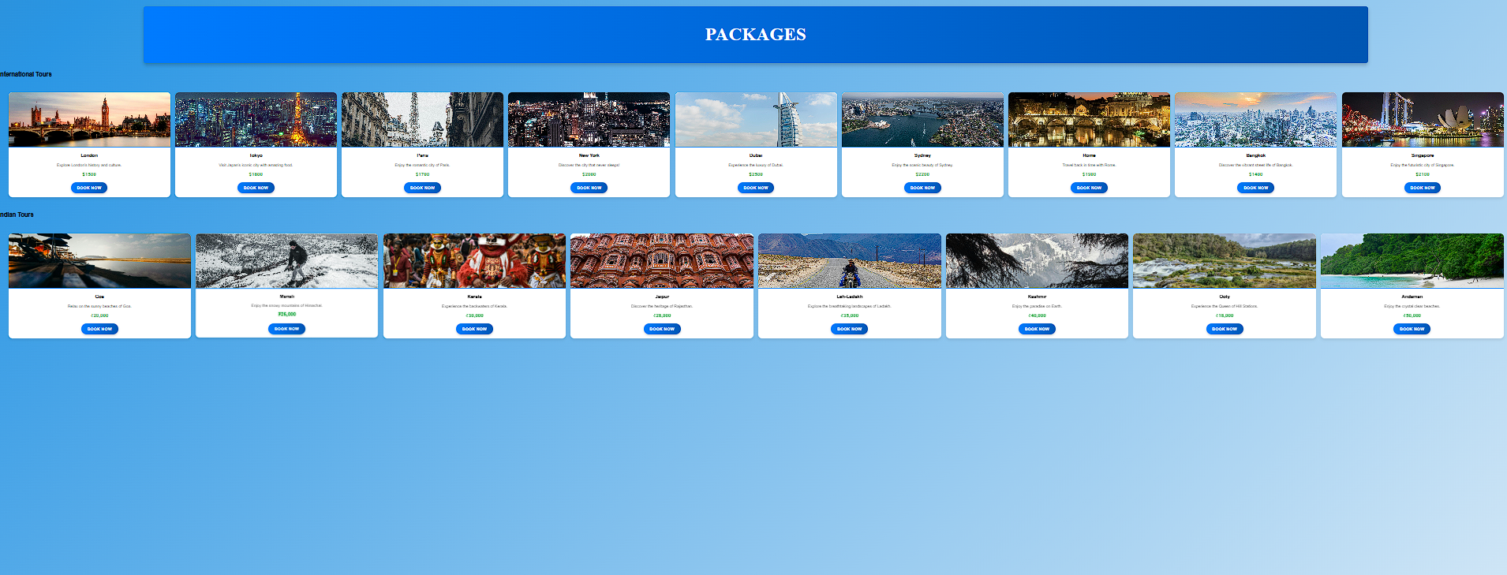

##### Conclusion

##### Experiment No.6

## Problem Statement:

## A. The user login form will allow registered users to log into their accounts. The form will require an email address and a password to authenticate the user. B. If the login is successful, the user should be redirected to the homepage or their user dashboard. (Beyond syllabus content) C. Use ****localStorage**** or ****sessionStorage**** to store authentication data such as the user’s email and login status. This ensures that once a user is logged in, they remain authenticated even after the page reloads or when they visit the site again. (Beyond syllabus content) Save the cart data to localStorage when items are added, updated, or removed. Retrieve and load the cart data from localStorage when the page loads. (Beyond syllabus content)

### Introduction

A smooth and engaging user experience is critical for a Tourism Management platform. JavaScript’s Web Storage API, which includes **localStorage** and **sessionStorage**, plays a vital role in maintaining user session state and preferences such as cart data without requiring a backend database or server session.

### Persistent Login using localStorage / sessionStorage

* The login system allows users to authenticate and continue accessing personalized content without needing to log in repeatedly.
* JavaScript Implementation:
  + On successful login: store **userEmail** and **isLoggedIn** flags in localStorage.
  + On every page load:
    - JavaScript checks if the login data exists in localStorage.
    - If yes, the user is auto-logged in and redirected to their dashboard or homepage.
  + On logout:
    - Clear the login data from localStorage to end the session.

### Benefits:

* Enhances usability with auto-login features.
* Supports session continuity across multiple visits to the tourism site.
* Useful for simple prototypes or static platforms without backend integration.

### Cart Management Using localStorage (Tourism Package Booking)

* When a user adds tourism packages to the cart, the cart data is saved in localStorage.
* The cart data persists even after page reload or browser close.
* On the cart or booking page, JavaScript retrieves and displays the saved packages.

### Benefits:

* Offers a personalized booking experience for users.
* Booking data remains intact even after browser restart.
* Enables frontend-only implementation of cart/booking functionality.

### Bonus Use Cases for Tourism Management:

* Save theme preferences (e.g., light/dark mode) using localStorage.
* Let users bookmark or favorite travel destinations or packages.
* Maintain user progress during multi-step booking processes.
* Store draft feedback or booking forms temporarily

**Code**

<!DOCTYPE html>

<html lang="en">

<head>

<meta charset="UTF-8">

<meta name="viewport" content="width=device-width, initial-scale=1.0">

<title>Login | World Travel Fusion</title>

<link rel="stylesheet" href="login.css">

<form action="login.php" method="POST"></form>

</head>

<body>

<!-- Login Page -->

<div class="login-container">

<h2>Welcome Back!</h2>

<p>Please sign in to continue</p>

<input type="text" id="username" placeholder="Enter your name">

<input type="email" id="email" placeholder="Enter your email">

<input type="password" id="password" placeholder="Enter your password">

<button onclick="login()">Sign In</button>

<p>Don't have an account? <a href="#">Sign Up</a></p>

</div>

<footer>

&copy; 2025 World Travel Fusion. All rights reserved.

</footer>

<script>

function login() {

let username = document.getElementById("username").value;

let email = document.getElementById("email").value;

let password = document.getElementById("password").value;

if (username && email && password) {

localStorage.setItem("loggedIn", "true");

window.location.href = "index.html"; // Homepage ला redirect

} else {

alert("Please enter all details!");

}

}

</script>

<script>

function signIn() {

// User successfully logged in

localStorage.setItem("loggedIn", "true");

window.location.href = "index.html"; // Redirect to home page

}

</script>

</body>

</html>

**Output**

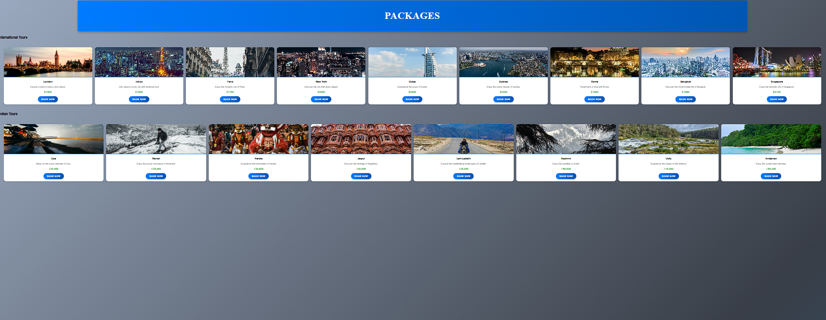

**Conclusion** In this experiment, we successfully implemented a simple user login and cart management system for a Tourism Management website using **JavaScript** and **Web Storage APIs** (localStorage sessionStorage). The login system allows users to log in using their credentials and persist their session across page reloads or future visits, enhancing the user experience.This experiment highlights how frontend-only techniques can be used to prototype real-world features such as **authentication** and **shopping cart persistence**, making it ideal for static web applications or academic projects.

**Experiment No.7**

### ****Problem Statement****

A. Develop a PHP script to handle user registration for the **Tourism Management website**. The script should accept input from users for their **name, email address, password**, etc. (all required fields for registration).  
B. Implement **error handling** to notify users of any issues during registration, such as **validation errors**.  
C. Provide **feedback** to the user upon successful registration, either through a **confirmation message or a redirect**

### ****Introduction****

User registration is a basic yet essential component of any interactive system.  
In the **Tourism Management** platform, registration helps users:

* Book and manage tour packages
* Save their travel history
* Access personalized recommendations
* View booking history and invoices

PHP is a powerful server-side language ideal for handling form data, processing user inputs, and interacting with databases.

### ****Core Elements of the PHP Registration Script****

### ****Form Handling****

* + The form collects user data like **name**, **email**, **password**, and **confirm password**.
  + The data is submitted using the **POST** method to a PHP script.

### ****Validation****

* + All fields must be **filled**.
  + **Email** is validated using **regex** to ensure it is properly formatted.
  + **Passwords** are checked for **minimum length** and **matching confirmation**.
  + Additional validation (optional): mobile number, special character checks, etc.

### ****Password Hashing****

* + Passwords are hashed using password_hash() before storing them in the database.
  + This ensures they are **not stored in plaintext**.

### ****Database Interaction****

* + PHP connects to the **MySQL database** using **MySQLi** or **PDO**.
  + The user data is inserted into a users table securely using **prepared statements**.

### ****Error Handling****

* + Errors are shown if:
    - Fields are empty
    - Email format is invalid
    - Passwords don’t match
    - Email already exists (duplicate account)
    - Database connection fails

### ****User Feedback****

* + After successful registration:
    - A success message is shown OR
    - The user is redirected to the **login page** for the tourism portal

## ****Key Features of PHP****

* **Server-side** language: runs on the server
* **Open-source** and free
* Works seamlessly with **HTML, CSS, JavaScript, and MySQL**
* Cross-platform: Windows, Linux, macOS
* Excellent support for **database operations**

**CODE**

<?php

// Database connection parameters

$servername = "localhost";

$username = "abhijeet61"; //

$password = "abhijeet"; //

$dbname = "tourism_db";

// Create connection

$conn = new mysqli($servername, $username, $password, $dbname);

// Check connection

if ($conn->connect_error) {

die("Connection failed: " . $conn->connect_error);

}

// Get POST data and sanitize

$name = $conn->real_escape_string($_POST['name']);

$email = $conn->real_escape_string($_POST['email']);

$password = $_POST['password'];

// Basic validation (Optional, can improve)

if (empty($name) || empty($email) || empty($password)) {

die("Please fill all required fields.");

}

// Hash the password for security

$hashed_password = password_hash($password, PASSWORD_DEFAULT);

// Check if email already exists

$sql_check = "SELECT * FROM users WHERE email='$email'";

$result = $conn->query($sql_check);

if ($result->num_rows > 0) {

die("This email is already registered. Please use another email.");

}

// Insert into database

$sql = "INSERT INTO users (name, email, password) VALUES ('$name', '$email', '$hashed_password')";

if ($conn->query($sql) === TRUE) {

echo "Registration successful! You can now <a href='login.html'>login</a>.";

} else {

echo "Error: " . $conn->error;

}

$conn->close();

?>

**Output**

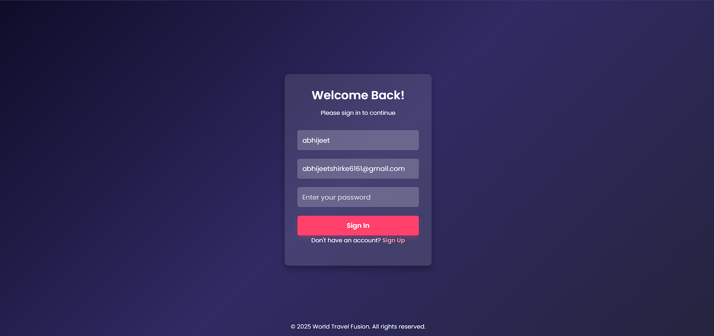

##### Experiment No. 8

**Problem statement:**

1. Develop a PHP script to handle user login for the Blog platform website. The script should accept input from users for their login credentials. (all required fields for login).
2. Provide feedback to the user upon successful login, either through a confirmation message or a redirect to a welcome page.
3. Implement error handling to notify users of login failures due to incorrect credentials or other errors.
4. Provide feedback to the user upon successful login, either through a welcome user name message or a redirect to a home page.

## ****Introduction****

A login system is a crucial part of the **Tourism Management Platform**, enabling registered users such as tourists or admin staff to access personalized services like:

* Viewing or booking tour packages
* Managing their profiles and bookings
* Accessing travel history and notifications

Using PHP for handling login ensures secure backend validation, safe password processing, and proper session control. It ensures that only authorized users can access protected content and functionalities of the platform.

The login system in PHP includes:

* Capturing user credentials through a login form
* Validating and sanitizing the input
* Comparing login details with records stored in a MySQL database
* Initiating a secure session on success
* Providing feedback or redirecting users appropriately

## ****Key Components of the Login System****

### ****Form Handling****

* The system accepts **email and password** from the login form.
* Data is submitted via the **POST method** to the PHP script (login.php).

### ****Input Validation****

* Ensures both email and password fields are not empty.
* Checks if the email is in valid format.
* Uses **prepared statements** to avoid SQL injection attacks.

### ****Password Verification****

* Passwords are **hashed using password_hash()** during registration.
* On login, password_verify() is used to compare the entered password with the stored hashed password.

### ****Database Authentication****

* Connects to a **MySQL** database (users table).
* Searches for the user using the entered email.
* Verifies if the password matches the stored hash.

### ****Session Management****

* On successful login, session_start() stores the user’s session data.
* The session allows access to **tourism features** like viewing packages, booking history, or admin dashboard.

### ****User Feedback****

* On success: Displays a **welcome message** or **redirects to home/dashboard page** (index.php, dashboard.php, etc.).
* On failure: Displays messages like **"Invalid credentials"** or **"User not found"**.

**Code**

<?php

session_start();

// Database credentials

$host = "localhost";

$user = "root";

$password = "";

$dbname = "tourism_db";

// Create connection

$conn = new mysqli($host, $user, $password, $dbname);

// Check connection

if ($conn->connect_error) {

die("Connection failed: " . $conn->connect_error);

}

// Check if form submitted

if ($_SERVER["REQUEST_METHOD"] == "POST") {

$email = trim($_POST['email']);

$password = $_POST['password'];

// Validate input

if (empty($email) || empty($password)) {

echo "All fields are required!";

exit();

}

// Prepare SQL statement

$stmt = $conn->prepare("SELECT id, name, password FROM users WHERE email = ?");

$stmt->bind_param("s", $email);

$stmt->execute();

$stmt->store_result();

// Check if user exists

if ($stmt->num_rows > 0) {

$stmt->bind_result($id, $name, $hashed_password);

$stmt->fetch();

// Verify password

if (password_verify($password, $hashed_password)) {

// Successful login

$_SESSION['user_id'] = $id;

$_SESSION['user_name'] = $name;

// Redirect to welcome/home page

header("Location: index.php");

exit();

} else {

echo "Incorrect password!";

}

} else {

echo " No user found with that email!";

}

$stmt->close();

}

$conn->close();

?>

**Output**



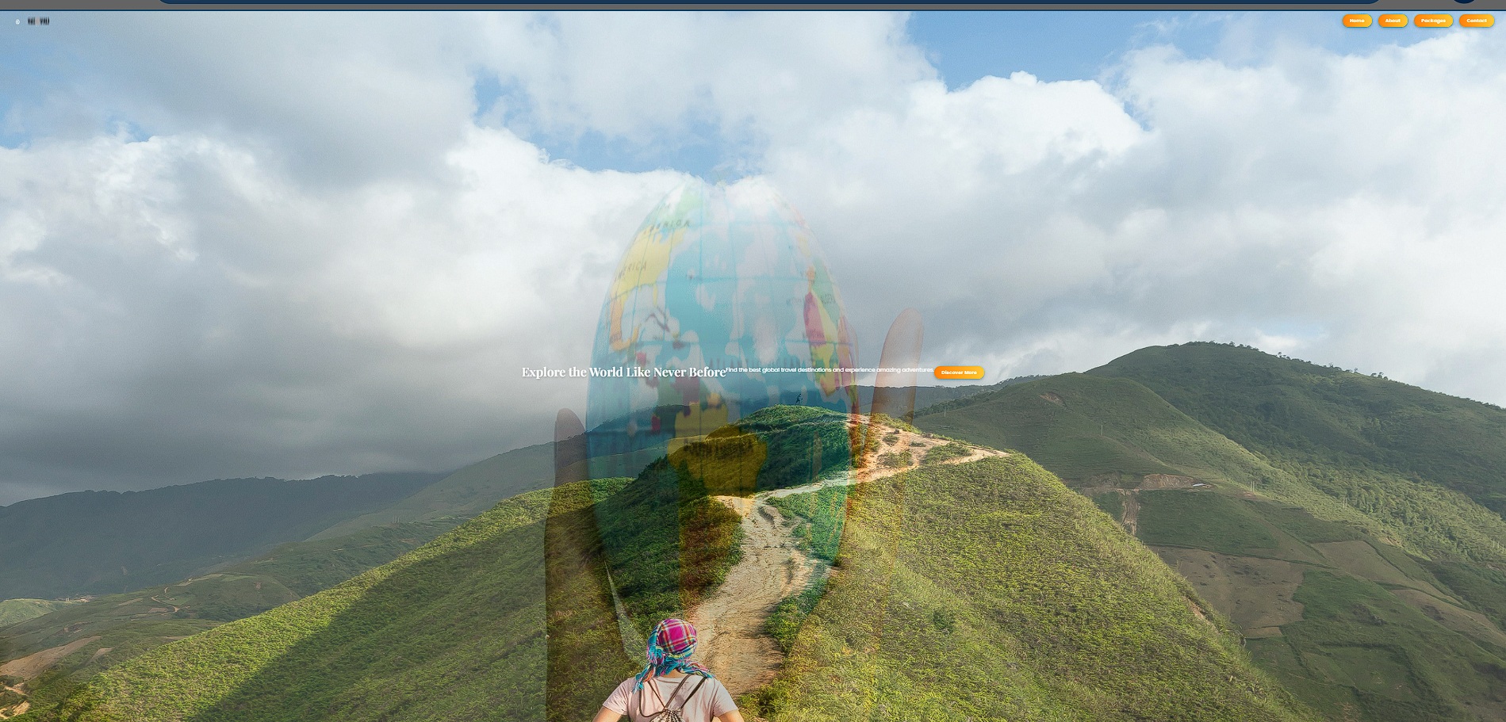

**Conclusion**

The login system developed for the **Tourism Management Website** ensures a secure and user-friendly authentication process. By using PHP and MySQL, the system handles user credentials efficiently through form submission, input validation, and database verification.

The use of password_hash() and password_verify() ensures secure password handling, while session_start() manages authenticated sessions for accessing personalized tourism features like booking and user dashboards.Overall, the PHP-based login system enhances the **security, reliability, and usability** of the Tourism Management Platform, providing a strong foundation for further development and integration of user-specific services.

**Experiment No. 9**

**Problem statement:**

1. Develop a PHP script that allows users to manage their shopping cart for an e-commerce website (e.g., a online blog platform ). The script should allow users to add items to their cart, view their cart contents, and remove items if needed.
2. Develop a PHP script to manage the cart for an website (e.g. online blog platform,) using MySQL. This script should allow users to add items to their cart, view their cart contents, and remove items from the cart. The cart data should be stored in the MySQL database to allow persistence across sessions.

### ****Introduction****

In any tourism or e-commerce platform, the **cart** plays a vital role in providing a seamless booking experience. This feature allows users to:

* Select desired **tourism packages or offers**
* Review and modify their **selected packages**
* Proceed to booking or checkout when ready

PHP, when combined with **MySQL**, offers a powerful solution to handle cart data dynamically and securely. By saving cart data in the database, users can resume their bookings even after leaving the site.

### ****Core Elements of the Tourism Cart Management System****

#### 1. ****Form & User Actions****

* Users interact with "Add to Cart" or "Remove from Cart" buttons.
* PHP scripts capture these actions via $_POST or $_GET.

#### 2. ****Database Design****

* A table like cart stores:
  + cart_id, user_id, package_id, package_name, price, quantity, added_date
* Optionally link user_id from session for persistent cart storage

#### 3. ****Add to Cart Functionality****

* On clicking “Add to Cart,” a PHP script:
  + Validates the package ID
  + Inserts it into the cart table
  + Updates quantity if already added

#### 4. ****View Cart Contents****

* A script fetches all cart items from the database for the logged-in user.
* Displays package name, price, quantity, and total cost

#### 5. ****Remove Items****

* Users can remove individual items using a delete button.
* PHP script deletes the selected item from the cart table.

#### 6. ****Session & Login Integration****

* Ensures that only logged-in users can access and modify the cart
* Uses $_SESSION['user_id'] to link carts with users

### ****Features of PHP Used****

* mysqli or PDO for database interaction
* session_start() for user tracking
* isset($_POST['add']), $_GET['remove'] for detecting cart actions
* Error handling and SQL injection prevention using **prepared statements**

**Code**

CREATE TABLE cart (

id INT AUTO_INCREMENT PRIMARY KEY,

user_id INT NOT NULL,

item_name VARCHAR(100) NOT NULL,

quantity INT NOT NULL,

price FLOAT NOT NULL,

added_on TIMESTAMP DEFAULT CURRENT_TIMESTAMP

);

<?php

session_start();

include 'config.php'; // Database connection

$user_id = 1;

// Add to Cart

if (isset($_POST['add_to_cart'])) {

$item_name = $_POST['item_name'];

$quantity = intval($_POST['quantity']);

$price = floatval($_POST['price']);

// Check if item already in cart for this user

$check_sql = "SELECT * FROM cart WHERE user_id=? AND item_name=?";

$stmt = $conn->prepare($check_sql);

$stmt->bind_param("is", $user_id, $item_name);

$stmt->execute();

$result = $stmt->get_result();

if ($result->num_rows > 0) {

// Update quantity if item exists

$update_sql = "UPDATE cart SET quantity = quantity + ? WHERE user_id=? AND item_name=?";

$stmt = $conn->prepare($update_sql);

$stmt->bind_param("iis", $quantity, $user_id, $item_name);

$stmt->execute();

} else {

// Insert new item

$insert_sql = "INSERT INTO cart (user_id, item_name, quantity, price) VALUES (?, ?, ?, ?)";

$stmt = $conn->prepare($insert_sql);

$stmt->bind_param("isid", $user_id, $item_name, $quantity, $price);

$stmt->execute();

}

header("Location: cart.php"); // Reload page after adding

exit();

}

// Remove from Cart

if (isset($_GET['remove'])) {

$id = intval($_GET['remove']);

$delete_sql = "DELETE FROM cart WHERE id=? AND user_id=?";

$stmt = $conn->prepare($delete_sql);

$stmt->bind_param("ii", $id, $user_id);

$stmt->execute();

header("Location: cart.php");

exit();

}

// Fetch Cart Items

$sql = "SELECT * FROM cart WHERE user_id=?";

$stmt = $conn->prepare($sql);

$stmt->bind_param("i", $user_id);

$stmt->execute();

$cart_items = $stmt->get_result();

?>

**Output**

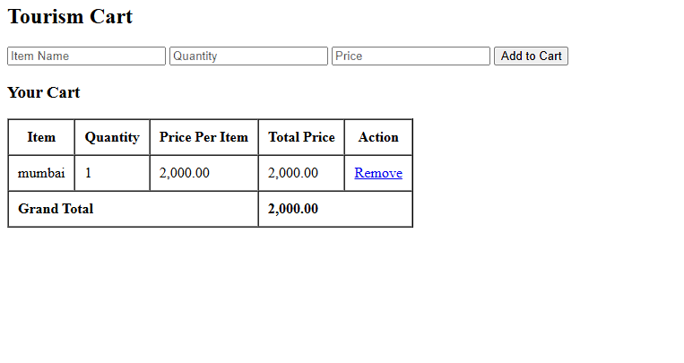

### ****Conclusion****

The Tourism Cart Management System, built using PHP and MySQL, provides a **smooth and reliable experience** for users booking tour packages.  
By enabling **add, view, and delete operations**, and storing data in a database, the cart becomes persistent, flexible, and personalized — essential features for a professional tourism website.

It lays a strong foundation for further enhancements like **checkout**, **payment gateway integration**, or **wishlist features** in the future.

**Experiment No. 10**

### Problem Statement

Develop a PHP script to handle the booking (checkout) process for users who want to finalize their travel package purchase. The script should:

* Validate user input (like name, contact, selected package, payment info),
* Process the booking data (cart or selected packages),
* Save booking details into a MySQL database,
* Provide clear feedback to the user about booking success or failure.

### Checkout Process in Tourism Management

* **User selects travel packages** (destinations, hotels, dates).
* User proceeds to **checkout/booking confirmation**.
* User submits booking details (personal info + selected packages).
* System **validates the input** and **stores booking info** securely in the database.
* User receives a confirmation message about booking status.

### Steps in Detail

1. **User Input Validation**
   * Check that required fields like name, email, phone, package selected, dates are filled.
   * Validate data formats (e.g., email syntax, phone number length).
2. **Sanitize Inputs**
   * Prevent security issues like SQL injection and cross-site scripting by sanitizing user inputs.
3. **Database Interaction**
   * Connect to MySQL database.
   * Insert booking details into bookings table (user info, package id, booking date, status).
4. **Booking Confirmation**
   * Return success or failure message to user.
   * Optionally, send confirmation email.

### PHP Script Outline

* Accept POST request with booking data.
* Validate and sanitize input.
* Connect to database.
* Insert booking into bookings table.
* Return JSON response (success or error).
* Show user confirmation message on frontend.

### Why is this important?

* **Ensures accurate booking info**: User mistakes or incomplete info are caught.
* **Secure data handling**: Protects system from attacks.
* **Reliable storage**: Bookings saved for later processing by admin or system.
* **User confidence**: Feedback ensures user knows booking is complete or needs correction.

**Code**

<?php

session_start();

header('Content-Type: application/json');

// DB connection

$host = 'localhost';

$user = 'root';

$pass = '';

$db = 'tourism_db';

$conn = new mysqli($host, $user, $pass, $db);

if ($conn->connect_error) {

echo json_encode(['success' => false, 'error' => 'DB connection failed: '.$conn->connect_error]);

exit;

}

// Check if user logged in

if (!isset($_SESSION['user_id'])) {

echo json_encode(['success' => false, 'error' => 'Please login to checkout.']);

exit;

}

$user_id = $_SESSION['user_id'];

// Check request method

if ($_SERVER['REQUEST_METHOD'] !== 'POST') {

echo json_encode(['success' => false, 'error' => 'Invalid request method']);

exit;

}

// Get cart data from POST (expected JSON)

$cart = $_POST['cart'] ?? '';

if (empty($cart)) {

echo json_encode(['success' => false, 'error' => 'Cart is empty']);

exit;

}

// Decode JSON cart to array

$cart_items = json_decode($cart, true);

if (json_last_error() !== JSON_ERROR_NONE || !is_array($cart_items)) {

echo json_encode(['success' => false, 'error' => 'Invalid cart data']);

exit;

}

// Validate each cart item

$total_amount = 0;

foreach ($cart_items as $item) {

if (

!isset($item['package_name']) ||

!isset($item['quantity']) ||

!isset($item['price']) ||

empty($item['package_name']) ||

!is_numeric($item['quantity']) ||

!is_numeric($item['price'])

) {

echo json_encode(['success' => false, 'error' => 'Invalid cart item data']);

exit;

}

$total_amount += $item['quantity'] * $item['price'];

}

// Begin transaction

$conn->begin_transaction();

try {

// Insert order

$stmt = $conn->prepare("INSERT INTO orders (user_id, total_amount) VALUES (?, ?)");

$stmt->bind_param("id", $user_id, $total_amount);

$stmt->execute();

$order_id = $stmt->insert_id;

$stmt->close();

// Insert order items

$stmt = $conn->prepare("INSERT INTO order_items (order_id, package_name, quantity, price) VALUES (?, ?, ?, ?)");

foreach ($cart_items as $item) {

$package_name = htmlspecialchars($item['package_name'], ENT_QUOTES, 'UTF-8');

$quantity = (int)$item['quantity'];

$price = (float)$item['price'];

$stmt->bind_param("isid", $order_id, $package_name, $quantity, $price);

$stmt->execute();

}

$stmt->close();

// Commit transaction

$conn->commit();

echo json_encode(['success' => true, 'message' => 'Checkout completed successfully!']);

} catch (Exception $e) {

$conn->rollback();

echo json_encode(['success' => false, 'error' => 'Checkout failed: '.$e->getMessage()]);

}

$conn->close();

?>

**Output**

. 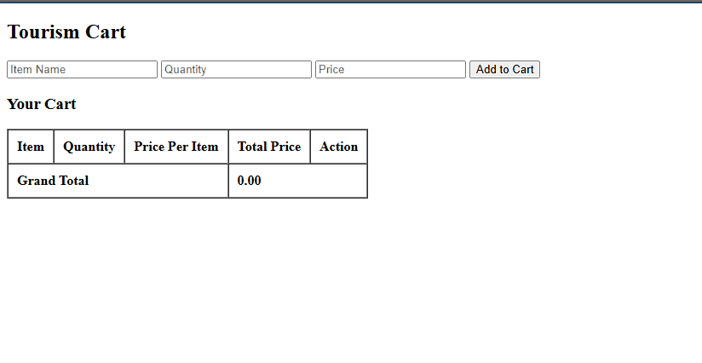

**Conclusion**

This checkout system enables users to complete their purchase of tourism packages smoothly and securely.

* **Security:** User information and order details are safely stored in the database.
* **Accuracy:** Each order along with its package details is recorded precisely.
* **User Experience:** Clear success and failure messages provide immediate feedback to users, helping them take appropriate next steps.
* **Business Utility:** This system allows the tourism company to effectively track sales and customer orders.

Overall, the process transforms the website from a simple informational portal into an interactive and functional platform that supports real business transactions.